

**Integrating Artificial Intelligence to enhance supply chain transparency and efficiency**

**MSc in Computer Science**

Student name

Student email

**Staffordshire University**

***A thesis submitted in partial fulfilment of the requirements of Staffordshire***

***University for the degree of Master of Science***

May 2024

Contents

List of Figures ii

Acknowledgments iii

Abstract iv

List of Abbreviations v

1 CHAPTER 1: INTRODUCTION 1

1.1 Background of Study 1

1.2 Problem Statement 2

1.3 Aims and Objectives 2

1.3.1 Aim of this project 2

1.3.2 Objectives of this project 2

1.4 Research Questions 3

1.5 Scope of the Study 4

1.6 Structure of the Study 4

2 CHAPTER 2: LITERATURE REVIEW 5

2.1 Introduction 5

2.2 Predictive Analytics in Supply Chain Management using SAP and AI 6

2.2.1 SAP's Role in Supply Chain Management 7

2.2.2 Real-world Applications 7

2.2.3 Predictive Models and Algorithms 7

2.2.4 SAP Tools & Accelerators 7

2.2.5 Case Studies 8

2.2.6 Challenges and Considerations 8

2.3 Development of Architecture for Digital Supply Chain (DSC) using Blockchain, IoT, and AI Technologies 8

2.3.1 Methodological Framework 8

2.3.2 Key Findings and Contributions 9

2.3.3 Critical Assessment 9

2.3.4 Challenges and Considerations 10

2.4 Blockchain-Based Supply Chain Management 11

2.4.1 Challenges and Considerations 11

2.3.2. Strategic Implications for SCM 13

2.4.2 Potential Benefits Beyond Security and Efficiency 13

2.4.3 Broader Considerations and Ethical Implications 13

2.5 Human resource management issues in supply chain management research 14

2.6 Risk-aware supply chain intelligence: AI-enabled supply chain and logistics management considering risk mitigation 15

2.6.1 Key Insights from Featured Articles 15

2.6.2 Critical Appraisal and Future Trajectories 16

2.7 A Comparative Analysis of Recent Advances 16

3 CHAPTER 3: RESEARCH DESIGN 20

3.1 Introduction 20

3.2 Research Philosophy 20

3.3 Research Approach 21

3.4 Research Strategy 22

3.5 Ethical considerations 23

4 CHAPTER 4: ANALYSIS 24

4.1 Design of Artefact 24

4.2 System Architecture 26

4.3 Implementation 27

4.4 Testing 36

4.5 Validation 39

4.6 Critical Evaluation 43

5 CHAPTER 5: Conclusion and Future Works 47

5.1 Conclusion 47

5.2 Future works 48

6 REFERENCES 50

# List of Figures

Figure 1: Use case diagram 27

Figure 2: Order Predictions 28

Figure 3: Results displaying at top end 28

Figure 4: Retailers management 29

Figure 5: Admin Portal 29

Figure 6: View Retailer 30

Figure 7: View manufacturer 30

Figure 8: View distributor 31

Figure 9: view products 31

Figure 10: Current approval 32

Figure 11: Pharmaceutical orders 32

Figure 12: View products 33

Figure 13: Approval code 33

Figure 14: Python code for product approval 35

Figure 15: Python code for login 36

Figure 16: Login validation results 37

Figure 17: Login form 38

Figure 18: Attempt failure 38

Figure 19: Login disabled 39

Figure 20: order likely not to approved 39

Figure 21: Admin 40

Figure 22: validating the credentials 40

Figure 23: Validation of area\ 41

Figure 24: Displaying categories 41

Figure 25: Validation of results 42

Figure 26: Prediction made on supply chain 42

Figure 27: precision and other values 43

Figure 28:Predicted values 43

# Acknowledgments

"I would like to express my sincere gratitude to my supervisor, [Name], for their unwavering support, guidance, and encouragement throughout my research journey. Their expertise and insights have been invaluable in shaping the direction and scope of this study.

I would also like to thank my colleagues, [Names], for their collaboration and feedback on various aspects of the research. Their constructive criticism and ideas have helped improve the work’s quality.

I am grateful to the participants who generously gave their time and shared their experiences, without whom this study would not have been possible.

Finally, I want to express my gratitude to my family and friends for their unwavering support, encouragement, and understanding during the ups and downs of the research process. Their love and belief in me kept me motivated and focused on achieving my goals."

# Abstract

In recent years, there has been a significant surge in the adoption of advanced technologies such as artificial intelligence (AI) and the Internet of Things (IoT), leading to a transformation in the supply chain management industry. This study focuses on exploring the applications of predictive analytics within supply chain management, with a particular emphasis on the integration of AI technologies. It examines the development of a digital supply chain architecture that incorporates AI, analyzing the associated methodological frameworks, key findings, and results.

The research also addresses human management issues within supply chain management, highlighting the potential of AI for implementing effective risk mitigation strategies. By comparing resources across different fields, the study underscores significant developments and identifies future trajectories for the industry.

The research design involves a comprehensive examination of various aspects, including the artefact, system architecture, implementation processes, and critical evaluations. The study's major contribution lies in providing in-depth insights into the role of emerging technologies in transforming current supply chain management practices, offering practical implications for various stakeholders.

# List of Abbreviations

AI – Artificial Intelligence

ML – Machine Learning

IoT- Internet of Things

# CHAPTER 1: INTRODUCTION

## Background of Study

Recently, artificial intelligence (AI) and blockchain technology have become very popular, especially in improving supply chain management. AI helps by making accurate predictions and making decisions quickly, while blockchain provides a secure way to record transactions, which improves transparency, efficiency, and reliability in supply chains. Currently, traditional supply chains face many problems like lack of transparency, inefficiencies, and being easily disrupted. These issues not only affect the systems themselves but also pose challenges to the end users and the broader global supply network. To meet consumer demands, it's becoming increasingly important to use new technologies like AI and blockchain. AI is great at analyzing large amounts of data and providing useful information that can help make better decisions. It also has the potential to improve many parts of the supply chain, from predicting product demand and managing inventory to maintaining equipment and optimizing delivery routes. This can help make supply chains more efficient, cut costs, and reduce problems. Blockchain technology can create a decentralized and secure system for recording data, which builds trust, transparency, and accountability among everyone involved in the supply chain. This technology is particularly good at making supply chains more open, traceable, and responsible.

Despite, the numerous advantages of opting for blockchain and artificial intelligence, they have been facing challenges with supply chain management, which includes data privacy, regulatory compliance, interoperability, etc. Alongside this, the integration adopts numerous problems, and supply chain connections. To manage the dynamic nature of supply chain systems, adaptive technologies can be employed, which helps to shift appropriate market demands and regulatory landscapes. The transformative potential for integrating artificial intelligence and blockchain technologies can be recognized as it explores effects, in which the technologies can be combined to address numerous key challenges, and able to develop opportunities in the context to supply chain management. Empirical study includes quantitative and sector-specific cases study, as this dissertation aims to study best practices, challenges and opportunities to integrate AI and blockchain and drive the solutions with artifacts.

## Problem Statement

Despite the growing interest and potential benefits, of the integration of artificial intelligence and blockchain technology within supply chain management, there are critical challenges and knowledge gaps that persist, which hinder adoption and implementation approaches within a real-world environment. In the literature review, the major focus will be on theoretical frameworks and conceptual models as integration needs to be done with supply chain management. There has been a lack of empirical evidence, which impacts the understanding of practical efficacy, limitations, and adaptability to adopt widespread adoptions of industry stakeholders.

Individual studies were also performed to explore the potential of artificial intelligence and blockchain within supply chain management, and notable gaps were identified for both technologies as able to optimize operational activities. The impacts will be made to predictive analytics and blockchain technology needs to be secure, ledger systems remain unexplored, and abilities limited to deploy technologies, which are helpful to manage supply chain management. while existing literature discusses AI and Blockchain integration at a high level, there is a dearth of sector-specific application studies that delve into the unique challenges and opportunities within specific industries. This gap impedes our ability to tailor AI and Blockchain solutions to meet the diverse needs and requirements of different sectors, hindering their practical applicability and effectiveness.

## Aims and Objectives

### Aim of this project

The major aim of this dissertation is to develop a comprehensive framework used to integrate artificial intelligence and blockchain for supply chain management. Additionally, this framework is used to focus on the improvement in the supply chain transparency, and able to optimize the current efficiency, and provide a resilient approach towards any type of disruption. By developing suitable actionable insights and validated strategies, this project aims to demonstrate suitable benefits for technologies in real-world supply chain scenarios.

### Objectives of this project

The following are the objectives of this dissertation: -

* One of the major objectives is to evaluate the practical efficiency of artificial intelligence technologies, their limitations, and adaptability towards supply chain processes and offer further evidence-based recommendations.
* The major focus will be on to access effects of blockchain and artificial intelligence integration within supply chain management. In this objective, the major focus will be to examine risks and recommend solutions to resolve them.
* To develop and apply quantitative models to assess the sustainability and ethical impacts of AI and Blockchain integration in SCM. This objective aims to provide data-driven insights into the implications of these technologies on sustainability metrics and ethical considerations, supporting the development of responsible and sustainable supply chain practices.
* To develop and assess frameworks or models, which ensure data privacy and security in context to supply chain management. It involves analysis of different regulatory requirements, and data sensitivity levels to design robust strategies for mitigating data-related risks.
* This objective focuses on facilitating a seamless information flow and collaboration between the supply chain stakeholders and ensures diverse systems and platform interactions.

## Research Questions

Scalability and interoperability challenges emerged, and have concerns related to privacy and security, which pose significant barriers to make integration of Artificial intelligence and blockchain technologies. Without any innovative solutions, these challenges can’t be addressed, and require widespread adoptions and effective systems integration to understand goals. The following are research questions which this dissertation will address:

1. How can empirical research validate and refine theoretical frameworks for integrating AI and Blockchain within specific supply chain contexts?
2. What are the synergistic effects of comprehensively integrating AI and Blockchain technologies in SCM, and how can they be leveraged to optimize supply chain operations?
3. What quantitative models can be developed to assess the sustainability and ethical impacts of AI and Blockchain integration in SCM?
4. What are the sector-specific challenges and opportunities for AI and Blockchain integration within industries such as pharmaceuticals, automotive, and food and beverage?
5. How can scalability, interoperability, data privacy, and security concerns be effectively addressed to facilitate the seamless integration of AI and Blockchain technologies in SCM?
6. What behavioral factors influence the adoption of AI and Blockchain technologies within supply chain organizations, and how can user acceptance be improved through effective change management strategies?

## Motivation of the study

The rapidly developing technology has caused several sector changes, among them supply chain management. Conventional supply chain systems are falling short in transparency and efficiency in the face of globalization and growing complexity. AI will help solve most of these problems by increasing operational efficiency, improving data transparency, and helping in risk mitigation.

Whereas a broad span of strategies exists meaningful to practice, and there exist validated frameworks, an unmistakable gap is felt when speaking about the practical application of such technologies. This doctorate thesis is then motivated by the willingness to connect this gap at these two ends: one concerning the integration of advanced technologies into supply chain management systems toward more efficient performance, and the other concerning the development of sustainable and resilient supply chains that create innovation and competitiveness in the global market.

## Scope of the Study

The scope of the study is defined in this section by focusing on the integration of artificial intelligence and blockchain technology within supply chain management. Along with this, the research aims to explore how these technologies can be integrated and able to enhance transparency, efficiency, and resilience across other industry sectors. The following are specific areas, which have been included in artefact development: -

1. Challenges and Barriers; The study also focuses on identifying and predict future trends in integrating AI and blockchain with supply chain management. It will also include technological advancements as the pharmaceutical industries are not able to understand its configuration and concepts.
2. Geographical considerations: While doing this study, the global perspectives can be considered, and specific attention can be provided to the numerous regions, and integration of artificial intelligence and blockchain technology to propose and innovate solutions to overcome these barriers.
3. Future trends and innovations: This study also aims to identify and predict future trends while integrating artificial intelligence and blockchain technology.

## Structure of the Study

Chapter 1: Introduction

The introduction delineates the context and relevance of integrating AI and Blockchain within SCM. It details the current supply chain challenges and outlines how AI's predictive analytics and Blockchain's secure systems can revolutionize SCM practices by enhancing transparency, reducing costs, and improving overall efficiency.

Chapter 2: Literature Review

This chapter reviews existing literature on the individual and combined applications of AI and Blockchain in SCM. It critically assesses the gaps in current research, particularly the lack of empirical evidence and sector-specific applications, and discusses how these technologies have been historically integrated within various industries.

Chapter 3: Research Design

The methodology chapter outlines the research philosophy, approach, and strategies employed to conduct this study. It includes detailed descriptions of the data collection and analysis procedures, emphasizing the use of quantitative models and empirical research to validate and refine the integration of AI and Blockchain in SCM.

Chapter 4: Analysis

The analysis chapter discusses the empirical findings from the research. It presents a critical evaluation of the data gathered, focusing on the validation of theoretical frameworks, the assessment of AI and Blockchain's practical efficacy within SCM, and the exploration of sector-specific applications.

Chapter 5: Conclusion and Future Works

The final chapter summarizes the findings and contributions of the dissertation, discusses the implications for SCM practice and theory, and outlines areas for future research. It emphasizes the significance of this study in enhancing the understanding of integrating advanced technologies in SCM and suggests directions for subsequent studies to build on this foundational work.

# CHAPTER 2: LITERATURE REVIEW

## Introduction

This dissertation chapter highlights a comprehensive overview focusing on artificial intelligence and blockchain technology integration with supply chain management. Along with this, the exploration helps to understand the crucial state of research, identifying gaps and highlighting numerous technologies, which helps to bring supply chain operations smoothly. In this section, the work from the different authors has been taken into consideration and the following are the primary objectives of doing a literature review:

1. Establish a Theoretical Foundation: Outline the theoretical underpinnings of AI and Blockchain technologies and their roles within SCM. This involves a detailed discussion of key concepts, definitions, and the evolution of these technologies in the context of supply chain operations.
2. Review Current Implementations: Examine existing applications of AI and Blockchain in various sectors of SCM, including pharmaceuticals, automotive, and food and beverage industries. This review will assess how these technologies are currently being used to optimize operations, mitigate risks, and enhance decision-making processes.
3. Identify Research Gaps: Highlight the areas in current research that lack depth or empirical support, particularly focusing on the integration of AI and Blockchain. This will include a critique of the methodologies used in existing studies and an evaluation of the empirical evidence supporting the benefits of these technologies in SCM.
4. Explore Challenges and Solutions: Discuss the challenges faced by organizations in adopting AI and Blockchain technologies within their supply chains. This includes technological, regulatory, and organizational barriers, and reviewing how current literature proposes to overcome these challenges.
5. Theorize Future Directions: Suggest potential areas for future research based on identified gaps and emerging trends in technology and market needs. This will involve a discussion on the evolving nature of AI and Blockchain and their anticipated impact on future SCM practices.

## Predictive Analytics in Supply Chain Management using SAP and AI

The article "Predictive Analytics in Supply Chain Management using SAP and AI," published in the Journal of Computer Sciences and Applications by Moyinuddeen Shaik and Khurram Qumar Siddque, explores the integration of predictive analytics within SAP systems, enriched by AI capabilities, to optimize supply chain processes. Shaik and Siddque (2023) establish the evolving landscape of supply chain management, emphasizing the transformative potential of combining predictive analytics, SAP, and artificial intelligence (AI). The paper sets the stage by outlining the complexities of modern supply chain management and the strategic importance of integrating predictive analytics within SAP systems, enhanced with AI, to navigate these challenges.

### SAP's Role in Supply Chain Management

The authors delve into SAP's pivotal role in supply chain management, providing a historical overview, core functionalities, and the technical architecture that facilitates the integration of predictive analytics and AI. This section is essential for understanding how predictive analytics can seamlessly enhance SAP-driven supply chain management, leading to more informed and efficient decision-making processes.

### Real-world Applications

The heart of the article lies in its extensive discussion of real-world applications, illuminated through case studies across various domains, including demand forecasting, inventory optimization, logistics and transportation, and supplier risk management. These examples demonstrate the tangible impacts of AI-powered predictive analytics on supply chain optimization, from hyper-accurate demand forecasting to autonomous inventory replenishment and proactive disruption mitigation.

### Predictive Models and Algorithms

Shaik and Siddique further elaborate on the selection of models and algorithms pivotal for deploying predictive analytics within the supply chain function. They cover a wide array of models, including demand forecasting, inventory optimization, supplier performance prediction, and predictive maintenance, among others. This section underlines the technical depth and analytical sophistication required to harness the full potential of predictive analytics in supply chain management.

### SAP Tools & Accelerators

An exploration of SAP-native tools, SAP-integrated solutions, and cloud-based options for data cleaning, preparation, and predictive modelling illustrates the comprehensive ecosystem available to enhance the capabilities of supply chain management systems. This segment of the paper provides a roadmap for organizations to leverage the synergy between SAP and AI technologies.

### Case Studies

The inclusion of case studies from leading companies like Schneider Electric, Unilever, Ford Motor Company, Maersk, and Nestlé offers insights into the successful implementation of predictive analytics in supply chain management. These examples highlight the challenges faced, solutions implemented, and significant outcomes achieved, emphasizing the practical benefits and transformative impact of the integrated approach.

### Challenges and Considerations

Despite the promising advancements, the paper does not shy away from discussing the inherent challenges and considerations of integrating predictive analytics with SAP and AI (Rajah et al., 2018). Data quality, model development, organizational change, and the talent gap are identified as critical hurdles to successful implementation, providing a balanced view of the potential obstacles organizations might face.

## Development of Architecture for Digital Supply Chain (DSC) using Blockchain, IoT, and AI Technologies

The article "Development of Architecture for Digital Supply Chain (DSC) using Blockchain, IoT, and AI Technologies" in the International Journal of Recent Technology and Engineering by Rashmi Sharma et al., July 2023, presents a comprehensive exploration of integrating blockchain technology with the Internet of Things (IoT) and Artificial Intelligence (AI) to enhance the adaptability and agility of supply chain operations. The paper underscores the complexity and challenges inherent in contemporary supply chains (Gohil & Thakker, 2021), proposing an integrated solution leveraging blockchain, IoT, and AI technologies. By categorizing supply chain issues and offering a fusion of these technologies as a solution, the authors present a novel architecture aimed at improving transparency, efficiency, and sustainability in supply chain operations. The study addresses the need for smarter, leaner digital supply chains (DSCs) that can meet the demands of modern economies and environmental sustainability.

### Methodological Framework

The methodology section delineates the process of implementing blockchain technology across the supply chain, detailing the integration of smart contracts, IoT, and AI to enhance operational efficiency. Through a structured approach involving the ledger layer, smart contract layer, transaction layer, and data input layer within a blockchain server, the study presents a clear pathway for digitizing supply chain operations. This integrated approach allows for a detailed examination of how each technology contributes to resolving specific supply chain challenges.

### Key Findings and Contributions

1. **Blockchain and Smart Contracts**: Highlighting the role of smart contracts as non-tampering software programs, the study discusses their potential to streamline and secure transactions across the supply chain.
2. **Integration with IoT and AI**: The paper elaborates on how blockchain can be synergized with IoT and AI to bolster the supply chain's flexibility and efficiency. Notably, the integration facilitates real-time tracking, improves data accuracy, and enhances decision-making through predictive analytics (De Giovanni, 2020).
3. **Challenges and Considerations**: Despite outlining the benefits, the study also acknowledges the challenges of integrating these technologies, including the need for standard operating procedures, legal compliance, and overcoming resistance to technological adoption within organizations.

### Critical Assessment

The study provides a foundational framework for the digital transformation of supply chains through the convergence of blockchain, IoT, and AI. However, it also prompts further inquiry into several areas:

* **Scalability**: How scalable is the proposed architecture in accommodating the vast and varying demands of global supply chains?
* **Security**: While blockchain offers enhanced security, the integration with IoT devices introduces new vulnerabilities that must be addressed (Ghonim et al., 2020).
* **Cost-Benefit Analysis**: An in-depth analysis of the financial implications of adopting this integrated technology solution would be beneficial for organizations considering digital transformation.

### Challenges and Considerations

1. **Operational Strategy Alignment**: The paper emphasizes that each company has its unique operational strategy and processes. Before adopting new technologies, companies must review their existing business practices to develop a coherent implementation plan that aligns with their operational strategies. This ensures that the technology integration enhances, rather than disrupts, current operations (McKinsey & Company, 2024).
2. **Inclusion of All Stakeholders**: Given the supply chain's vast network of internal and external stakeholders, it's critical to design a technology usage flow that includes and benefits all parties involved. This consideration is vital for ensuring that the adoption of blockchain, IoT, and AI technologies brings value to every participant in the supply chain, from suppliers to consumers.
3. **Financial Planning and Investment**: Implementing new technologies, particularly those as advanced and integrated as blockchain, IoT, and AI, can be costly.
4. Organizations must develop a strong financial plan and understand the unit economics behind the technology investment. A long-term focus on technology investment and its return is essential for justifying the initial costs and ensuring sustainable benefits (Uddin et al., 2023).
5. **Training and Skill Development**: The paper points out that blockchain, IoT, and AI technologies are relatively new and may present a steep learning curve for existing personnel. Organizations must invest in training sessions, seminars, and continuous education to equip their staff, managers, and other stakeholders with the knowledge and skills needed to effectively utilize these technologies.
6. **Legal Compliance and Data Security**: As the integration of these technologies involves the collection, storage, and processing of vast amounts of data, legal compliance becomes a significant challenge. Organizations must navigate the complexities of data privacy laws, smart contract regulations, and other legal requirements to ensure that their digital supply chain operations are compliant and secure (Latif et al., 2021).
7. **Technical and Resource Challenges**: Smaller companies or those with limited resources may find it particularly challenging to adopt these technologies due to the high costs and technical expertise required. This consideration underscores the need for scalable solutions and support mechanisms to enable wider adoption across different sizes and types of organizations.
8. **Standard Operating Procedures (SOPs)**: For the effective integration of blockchain, IoT, and AI into supply chain networks, standard operating procedures must be established. These SOPs should detail all activities, processes (Trisninawati et al., 2023), and operations to ensure a smooth transition and effective utilization of the technologies across the supply chain (McKinsey & Company, 2024).

## Blockchain-Based Supply Chain Management

The chapter "Blockchain-Based Supply Chain Management," contributed by Anil Kumar Gupta and co-authors, provides a thorough examination of how blockchain, artificial intelligence (AI), machine learning (ML), and other digital technologies can revolutionize supply chain management (SCM). By focusing on enhancing transparency, security, and efficiency, the chapter outlines a comprehensive framework for integrating these technologies to address the multifaceted challenges present in traditional supply chains (Gupta et al., 2022). The chapter begins by identifying the critical role SCM plays in product development, from raw material acquisition to customer delivery (Asmussen and Møller, 2020). The necessity for a secure SCM system is underscored by the risks associated with counterfeit products entering the market, particularly in sensitive sectors like pharmaceuticals. The authors argue for the integration of AI to enhance decision-making processes and blockchain to secure SCM, highlighting the importance of digitalization in combating the infiltration of counterfeit goods. The authors propose a digital supply chain management (DSCM) model that leverages blockchain for its immutable ledger capabilities, AI and ML (Basuki, 2021) for intelligent decision-making and automation, and digital technologies for real-time tracking and control. The proposed model aims to cover every SCM phase, ensuring security, efficiency, and transparency. This integration promises significant advancements in forecasting, procurement, logistics, operations, and customer service.

### Challenges and Considerations

Implementing a blockchain-based SCM system, as described in the chapter, involves navigating several complex challenges:

1. **Technical Complexity and Integration**: The seamless integration of blockchain, AI, and ML technologies within SCM systems requires sophisticated technical expertise. Companies must address how these disparate technologies will communicate and operate in unison to achieve the desired SCM outcomes (Eriksson et al., 2023).
2. **Data Privacy and Security**: While blockchain offers enhanced security features, the incorporation of AI and ML raises concerns about data privacy and protection. The system must safeguard sensitive supply chain data against breaches while adhering to global data protection regulations.
3. **Scalability and Performance**: The proposed system must efficiently handle the vast amounts of data generated across the supply chain and scale to accommodate growth.

Balancing blockchain's immutable record-keeping with the dynamic, real-time decision-making capabilities of AI and ML presents a significant technical hurdle.

1. **User Adoption and Training**: For successful implementation, all supply chain stakeholders must embrace the new system. This challenge includes educating users on the benefits of the blockchain-based SCM and training them to effectively use the technology (Huang et al., 2023).
2. **Regulatory Compliance**: Navigating the regulatory landscape, particularly in industries like pharmaceuticals, where counterfeit products pose serious health risks, is crucial. The system must comply with industry-specific regulations and standards across different jurisdictions.
3. **Cost Implications**: The initial setup and ongoing operation of a blockchain-based SCM system entail considerable costs. Organizations must evaluate the return on investment and how the adoption of these technologies affects their bottom line.
4. **Interoperability**: Ensuring the proposed system can interact with existing SCM systems and technologies used by suppliers, manufacturers, and customers is essential for broad adoption.

### 2.3.2. Strategic Implications for SCM

The chapter also underlines a strategic shift towards a more interconnected and transparent supply chain ecosystem. Blockchain's decentralized nature allows for a shared, immutable ledger that enhances trust among all stakeholders, from suppliers to consumers. This strategic pivot emphasizes collaboration over competition, promoting a supply chain environment where data sharing becomes the norm, leading to improved efficiency and reduced discrepancies.

### Potential Benefits Beyond Security and Efficiency

While the primary focus is on enhancing security and operational efficiency, the integration of blockchain and AI in SCM extends to potential benefits such as:

* **Enhanced Product Traceability**: The immutable nature of blockchain enables unparalleled traceability of products through the supply chain. This feature is crucial for industries where authenticity and compliance with safety standards are paramount (Wong et al., 2024).
* **Automated Compliance**: AI algorithms can automate the compliance process by analyzing supply chain data against regulatory requirements. This automation can significantly reduce the administrative burden and ensure continuous compliance.
* **Predictive Analytics for Demand Forecasting**: The integration of ML techniques offers predictive analytics capabilities, enabling more accurate demand forecasting. This advancement could lead to optimized inventory levels, reducing both shortages and overstocks (Asmussen and Møller, 2020).

### Broader Considerations and Ethical Implications

As companies move towards implementing these technologies, broader considerations and ethical implications emerge:

* **Environmental Impact**: The energy consumption associated with blockchain, particularly proof-of-work (PoW) blockchain networks, raises environmental concerns. Future SCM systems will need to balance technological benefits with environmental sustainability.
* **Labor Market Impact**: The automation and efficiency gains from AI and blockchain integration could disrupt labour markets within the SCM sector. Addressing the potential displacement of jobs with strategies for reskilling and workforce development will be essential.
* **Data Monetization and Privacy**: With the digitalization of SCM, questions arise about the monetization of supply chain data and the privacy of sensitive information. Ensuring that data handling practices are transparent and equitable will be crucial for maintaining stakeholder trust.

## Human resource management issues in supply chain management research

The synthesis of Human Resource Management (HRM) within Supply Chain Management (SCM) as presented by Nils-Ole Hohenstein, Edda Feisel, and Evi Hartmann offers a profound insight into the evolving landscape of SCM research. From 1998 to 2014, this scholarly effort thoroughly documents and analyses peer-reviewed literature, marking a significant change in SCM research by acknowledging the crucial role of human factors.

1. **Exploration of Global Mindset in SCM:** The noted lack of discourse on developing a global mindset among SCM professionals suggests an urgent need for research focusing on cross-cultural management (Goldsby et al., 2024), international HRM practices, and their implications for global supply chain efficiency. Future studies could explore strategies for cultivating a global perspective, including international rotations, multicultural team building, and cross-cultural leadership training.
2. **Detailed Analysis of Compensation Structures:** The scant exploration of compensation structures in SCM positions highlights an opportunity to delve into how different reward systems influence employee motivation, retention, and performance within the supply chain. Research could compare traditional versus performance-based compensation models and their impact on achieving supply chain objectives.
3. **Integration of Technological Acumen:** The emerging importance of technology in SCM, including AI and blockchain, calls for research into how HRM can facilitate the development of technological competencies among SCM professionals. Studies might investigate the most effective training programs, the role of digital literacy in SCM roles, and the integration of technology-focused roles within the supply chain (Shahid et al., 2020).
4. **Sustainability and Ethical Considerations in SCM:** Given the increasing focus on sustainability and ethics in global business practices, there's a gap in understanding how HRM practices within SCM can promote sustainable and ethical supply chains. Future research could explore the role of HRM in enforcing sustainability practices, ethical sourcing, and corporate social responsibility within SCM (Oluwafunmilayo Esan et al., 2024).
5. **The Impact of Remote Work on SCM:** The recent shift towards remote work presents an unexplored area within SCM research. Investigating how remote work affects supply chain coordination, communication, and performance could provide valuable insights for HRM practices adapted to the new work environment (Attaran, 2020).

## Risk-aware supply chain intelligence: AI-enabled supply chain and logistics management considering risk mitigation

"Risk-aware supply chain intelligence: AI-enabled supply chain and logistics management considering risk mitigation," an editorial in Advanced Engineering Informatics, Volume 42, was written by Wei Yan, Junliang He, and Amy J.C. Trappey (Boute & Udenio, 2021). It takes a critical look at how Artificial Intelligence (AI) is being used in supply chain and logistics management, with a focus on how to strategically reduce risks. This academic paper stresses how important modern supply chains are for strengthening global and regional economies while handling the rough seas of uncertainty that come with logistics operations.

### Key Insights from Featured Articles

* **Optimization Amidst Uncertainty:** It brings to light various scholarly contributions that leverage AI to navigate uncertainties within the supply chain. Notable is the work by Zhen et al., which employs a stochastic approach to optimize closed-loop supply chain networks, demonstrating the prowess of AI in enhancing decision-making under ambiguous conditions.
* **Yard Crane Scheduling Under Uncertainty:** He et al.'s investigation into yard crane scheduling amidst uncertainties further underscores the editorial's theme, introducing an innovative model aimed at optimizing operational efficiencies while mitigating risk—a testament to the transformative impact of AI in logistical operations (Liu et al., 2021).
* **Data-driven Risk Analysis:** The editorial lauds Xu et al.'s quantitative approach to operational risk analysis in e-commerce logistics, showcasing how AI, through the analysis of vast datasets, can unveil insights into operational vulnerabilities, paving the way for informed risk mitigation strategies.

### Critical Appraisal and Future Trajectories

While the editorial and the encompassed articles underscore significant strides in AI's application within supply chain management, they also present a fertile ground for further scholarly inquiry:

* **Real-world Applicability and Ethical Considerations:** The editorial, while robust in its theoretical and methodological innovations, necessitates a deeper dive into the practical application of these AI-driven strategies across diverse logistical landscapes. Additionally, the ethical ramifications of AI, particularly concerning data stewardship and privacy, emerge as critical areas for future discourse (Fritz, 2023).
* **Expansion to Holistic Risk Management:** While operational and logistical risks are extensively covered, extending this discourse to encompass broader risk categories such as geopolitical, environmental, and socio-economic factors could yield a more holistic understanding of supply chain vulnerabilities (Aprianto, 2021).
* **Sustainability and Social Responsibility:** Future research directions should also explore AI's role in promoting sustainability and ethical supply chain practices, addressing the growing demand for supply chains that are not only efficient but also socially responsible and environmentally sustainable (Schinckus et al., 2019).

## A Comparative Analysis of Recent Advances

The table below shows the range and depth of the current study that is being done on the merging of AI, Blockchain, and SCM. It shows that most people agree that these technologies have the potential to change everything.

***Source Title Advancements Limitations Techniques How AI Could***

***Used Enhance***

***Functionalities***

|  |  |  |  |  |  |
| --- | --- | --- | --- | --- | --- |
| *Kamble, S.S.,*  *Gunasekaran, A., & Gawankar, S.A.*  *(2020)*  *Queiroz, M.M., &*  *Wamba, S.F. (2019)* | "Sustainable Industry 4.0 framework: A systematic literature review identifying the current trends and future perspectives" | Introduces a sustainable Industry 4.0 framework, identifying AI and Blockchain as pivotal for sustainable SCM practices. | Limited empirical data on the direct impact of these technologies on sustainability metrics. | Systematic literature review | AI could optimize resource allocation and predict sustainability outcomes, enhancing efficiency. |
| "Blockchain adoption challenges in the supply chain: An empirical investigation of the main drivers in India and the USA" | Empirically investigates the drivers and challenges of Blockchain adoption in SCM in India and the USA. | Focuses primarily on Blockchain, with less emphasis on the integration with AI. | Empirical investigation using survey data | AI can identify patterns in adoption challenges and drivers, offering personalized strategies for overcoming barriers. |
| *Min, H. (2019)*  *Treiblmaier, H. (2018)* | "Blockchain technology for enhancing supply chain resilience" | Discusses the potential of Blockchain to enhance supply chain resilience by improving transparency and security. | Theoretical exploration with a need for  practical implementation cases. | Conceptual analysis | AI-driven analytics can predict disruptions and automate decision-making to mitigate risks, improving resilience. |
| "The impact of the blockchain on the supply chain: A theory-based research framework and  a call for action" | Presents a theory-based research framework for Blockchain's impact on SCM and calls for empirical research. | Lacks empirical validation of the proposed framework. | Theoretical framework development | AI could operationalize the framework through predictive modelling and simulation, validating theoretical constructs. |
| *Choi, T.M., Wen, X.,*  *Sun, X., & Chung,*  *S.H. (2020)* | "The mean-variance approach for global supply chain risk analysis with air logistics in the blockchain technology era" | Applies the mean-variance approach to analyze global supply chain risks in the era of Blockchain, focusing on air logistics. | Specific to air logistics, limiting generalizability across all SCM areas. | Mean-  variance approach for risk analysis | AI algorithms could enhance risk assessment by dynamically adjusting to new data, improving accuracy and responsiveness. |
| *Saberi, S.,*  *Kouhizadeh, M., Sarkis, J., & Shen, L. (2019)* | "Blockchain technology and its relationships to sustainable | Investigates the  relationship between Blockchain technology and | The study is conceptual with a need for empirical studies to test | Conceptual analysis, literature review | AI can facilitate the tracking and evaluation of sustainable practices, |
| *Yan, W., He, J., &*  *Trappey, A.J.C. (2019)*  *Heckmann, I.,*  *Comes, T., & Nickel,*  *S. (2015)* | supply chain management" | sustainable SCM, emphasizing improved sustainability practices. | the propositions. |  | it is identifying areas for improvement. |
| "Risk-aware supply chain intelligence: AI-enabled supply chain and logistics  management considering risk mitigation" | Highlights AI's potential in optimizing supply chain operations and risk mitigation within the context of dynamic, complexly networked systems. | Focus on risk mitigation with limited discussion on broader SCM efficiency and transparency. | Editorial overview of articles in a special issue | AI could provide real-time risk assessment and  management,  tailoring mitigation strategies to specific threats. |
| "A critical review on supply chain  risk – definition, measure, and modelling" | Offers a critical review of supply chain risk, emphasizing the need for  definition, measure, and modelling. | It may not specifically address the integration of AI and Blockchain technologies in SCM. | Literature review on  supply chain risk | AI models can enhance risk definition and measurement by  integrating diverse data sources, offering predictive insights. |
| *Gan, V.J.L., Cheng,*  *J.C.P. (2015); Alharbi, S., Wang, P., Davy, P.*  *(2015); He, J.L.,*  *Huang, Y.F., Chang,*  *D.F. (2015)* | Various papers on dynamic SCM  formulation, sustainable container supply chains, and optimization techniques. | Address dynamic supply chain formulation, sustainable container supply chains, and optimization techniques. | Each paper focuses on a specific aspect of SCM, possibly limiting the  comprehensive view of AI and Blockchain integration. | Various, including agent-based modeling and simulation-based heuristic methods | AI can dynamically adapt and optimize supply chain models in real time, enhancing both sustainability and efficiency. |

## Analysis of problem/improvement

The main purpose of the section is to identify the current challenges in supply chain management and further investigate possible improvements enabled by integrating artificial intelligence into the system. The conventional supply chain management systems in use today have a number of shortcomings, such as lack of transparency, inefficiency, and susceptibility to shocks. These issues have been exacerbated by the global nature of modern supply chains, which require seamless coordination among the stakeholders. Below are the key issues that traditional supply chain management is associated with:

* Lack of Transparency: Traditional supply chains are mostly characterized by opacity of their processes and flow, stretching visibility over different stages in the supply chain. This opaqueness often stretches to the possibility and efficiency of tracing products to source and ascertaining their authenticity. A lack of transparency can result in fraud, product counterfeiting, and inefficiencies in recall processes.
* Operational Inefficiencies: Traditional supply chains are inefficient, as fragmented data systems, manual processes, and delays in the sharing of information result in an increase in costs and lead time, and less than optimal inventory management.
* Risk and Resilience: There are several potential risks that a traditional supply chain faces, such as those from natural disasters, geopolitical events, and market fluctuations. The system lacks real-time data and predictive capability that may have helped in anticipating such risks and mitigating the same, therefore resiliencing the supply chain.

Improvements needed in the supply chain management system are effected:

* Transparency Enhanced: AI can provide increased transparency and traceability throughout a supply chain. It can track the flow of goods, detect irregularities, and prove authenticity by using advanced data analytics. This increased transparency is able to reduce fraud, enhance recall processes, and increase trust among the stakeholders.
* Operational Efficiency: AI can be utilized in various aspects of the supply chain management process to drive efficiencies in demand forecasting, inventory management, and logistics. Machine learning algorithms use vast volumes of data to make accurate predictions of demand and reduce excess inventory while making the logistic processes seamless. The automation capabilities of AI enhance efficiency by reducing dependence on manual processes and causing less delay in sharing information.
* Risk Mitigation and Resilience: AI-powered predictive analytics spot risks way in advance, thereby enabling one to identify the potential ones and develop proactive mitigation strategies. Real-time insights provided by AI can enable supply chain managers to react to the fast-changing conditions and help manage risks more effectively, thereby improving the overall resilience of the supply chain.

In this research, the identification of these problems and implementation of AI-driven solutions are taken into consideration for the developed artefact with appropriate web-based solutions, integrating advanced technologies focused on AI. Within this, AI adoption presents frameworks that consider traditional supply chain management challenges for enhancing transparency, efficiency, and resilience. The infusion of AI into the present supply chain management delineates opportunities to tackle existing problems and make innovation in this important sector.

# CHAPTER 3: RESEARCH DESIGN

**3.1 INTRODUCTION**

This paper follows a mixed-method approach, wherein both quantitative and qualitative methodologies would apply to explore the adoption of AI in supply chain management. A quantitative approach draws from Ghanad (2023). In this regard, using data retrieved online showing operational efficacy of the proposed model for an optimized supply chain is involved. The qualitative approach provides an in-depth understanding of the context through literature review and work by others that supports empirical findings.

This mixed methodology will put in place a strong and iterative development process for technological artifacts, thus following all of the guiding principles by Nagpal et al. (2021), and guaranteeing practical applicability rather than just theoretical value.

This chapter aims to provide a clearly expressed and detailed description of the components of the research design, including the philosophical underpinnings, methodological approach, process of artifact development, and validation techniques. Further, certain ethical issues associated with the deployment of technological solutions within healthcare-related supply chains are discussed.

Finally, it presents the limitations involved during the process of conducting this study. The chapter sets the scene for understanding the procedures to be followed for the development of artifacts by articulating comprehensively the research design, hence ensuring the study will be performed with rigorous academic standards so that, in the end, valuable knowledge would have been contributed to the field of supply chain management, particularly in the pharmaceutical sector.

**3.2 RESEARCH PHILOSOPHY**

It is for these reasons that this dissertation shall adopt the pragmatist philosophy, which is most appropriate in solving practical problems, as it puts into play both objective and subjective knowledge to drive home the point. Pragmatism describes truth as the outcome that comes as an end result of an idea or theory in practice. Emphasis, therefore, lies with functionality rather than theoretical purity. It is supportive of the combination of various methodological approaches, such as qualitative and quantitative analyses, and is open to technological and process innovations which can adapt to the nature of the pharmaceutical industry.

In such a context, the pragmatist approach contributes to the choice of relevant methods allowing analysis of the complexities in the integration of AI technology into one coherent system about real-time supply chain problems. Iterative development, based on empirical grounding, would allow for continuous improvement through performance feedback and user interaction. The stakeholder views, represented in this research by regulatory bodies, health professionals, and end-users, reflect the need for the artifact to not only meet the technical specifications laid down but also to adapt to ethical standards and practical needs (Merkuryeva et al., 2019).

**3.3 RESEARCH APPROACH**

The research approach makes use of the design science methodology, most appropriate for developing and evaluating artifacts in complex problem solutions. The main constituents of the design science process are iterative development and refinement of an artifact, in this case, the supply chain system. By using this methodology, the system is repeatedly being evaluated and improved by performance feedback from users and user interaction. Therefore, this will enable the attainment of the functional goals of the project while satisfying the real-world demand (Jodlbauer et al., 2023).

The design science approach entails several iterations of building, testing, and refinement. This prototype has been developed using qualitative data from the literature. It will be rigorously tested and refined in order to establish its effectiveness in ensuring improved supply chain transparency, efficiency, and compliance.

**3.4 RESEARCH STRATEGY**

The strategy of the research ranges from a structured process that guides the development of the artifact from conceptualization to validation. To quote, as Gogo & Musonda, 2022 write, the strategy involves detailed planning, execution, and analysis phases that assure a final product respectful of theoretical frameworks but practically viable and scalable.

1. **Conceptualization:**

Literature review: At this stage, a review of extant literature will be done in order to bring out the gaps that exist in the current supply chain systems and then see how AI technologies can overcome these deficiencies. This will then form the basis for coming up with design specifications of the artifact and functional requirements.

1. **Design and Development:**

The design and development phase follows conceptualization. This phase is simply the application of design principles and technologies in creating a preliminary supply chain system. Such insights from the literature review, together with user requirements, shall guide the phase in ensuring conformance of the artifact to industry standards and practical needs.

1. **Testing and Refinement:**

After the prototyping phase, rigorous testing ensures that the developed prototype can measure up to the performance standards expected by the user. Testing is done through simulations of scenarios, unreal and real, in order to test the functionality and robustness of the system. The results of testing will be used in refining and tuning the system with the implementation of technical adjustments, feature enhancements, and user interface improvement measures for improved general usability and efficiency.

The unit testing approach has been followed by Gupta & Khan, 2016, wherein specific codes of the application have been tested and simulated to evaluate specific portions of code of the application.

**Validation:**

The final phase involves validating the artifact against the initial objectives and industry needs. Validation demonstrates the artifact's efficacy in improving supply chain transparency, efficiency, and compliance. This phase involves stakeholder feedback, including input from industry experts, regulatory authorities, and end-users, to ensure the system’s relevance and effectiveness.

**3.5 ETHICAL CONSIDERATIONS**

Developing a new artifact integrating AI necessitates addressing numerous ethical considerations, particularly within the pharmaceutical industry. In other words, technological innovation must take into consideration patient safety, integrity of data, and adherence to regulations.

1. **Data Protection:**

The most important from the ethics side has to do with protection against data breaches. Pharmaceutical supply chains contain a huge amount of sensitive information, including patients' data and business and product-related critical information. This calls for assurance regarding the security and privacy of data. Since all artifacts will be developed under strict data protection and privacy laws like the GDPR, appropriate measures of protection and standards while dealing with personal information shall be adhered to.

1. **Algorithmic Fairness and Non-Discrimination:**

This brings in another ethical issue with technology bias and discrimination. A supply chain system with algorithmic decision-making capacity could bring incredible biases into drug distribution, that would mainly go to certain regions or demographics, thus causing unequal drug access. A system has to be designed in this context that satisfies fairness and transparency in algorithm processes for the decisions to be justifiable and nondiscriminatory.

1. **Stakeholder Impact:**

A new system can introduce and disrupt the normal operating environment within the existing supply chains, which may have varying effects on the stakeholders. Ethical deployment considers these effects and seeks to carry out stakeholder analyses, including affected parties throughout all stages of system development and implementation. This step will ensure that the system meets the needs of all stakeholders while limiting adverse impacts to the bare minimum.

1. **Regular Audits and Training:**

The regularity of the audit and assessment could be ensured in order to prove conformance to ethical standards and other regulatory requirements. Development of training programs for educating users of this new system about ethical implications and maintaining high ethics in their operations shall also be done.

Importance to note is that in ethical concern, the research will ensure that the development and implementation of AI into pharmaceutical supply chains are done in a responsible manner in the best interests of the safety of patients, integrity of data, and fairness. Only in this way will this all-combined approach be directed towards a common goal: improving supply chain management with technological innovation while considering the highest standards of ethics.

# CHAPTER 4: ANALYSIS

**4.1 Design of Artefact**

The artefact designed for this dissertation is an all-comprehensive web-based supply chain management system. This will be achieved by incorporating advanced technologies in the area of HTML, CSS, JavaScript, and machine learning to improve operational efficiency and security. Structurally, two major functions are played by this artefact: detecting anomalies on the front page and prediction of approval processes within the supply chain. This section describes the design and architecture of the artefact.

**4.1.1 Overview of the Artefact**

The system is organized through a few major components:

1. **Front-End User Interface (UI):**

It is developed using HTML, CSS, and JavaScript to build the UI for intuitive navigation and access to a range of SCM functions such as real-time data visualization, order tracking, and inventory management.

1. **Anomaly Detection:**

This feature, applied on the front page, utilises JavaScript with machine learning algorithms that start detecting any strange patterns or discrepancies in the incoming data stream. This would include surprising changes in order quantities, price errors, or other irregularities from suppliers.

1. **Approval Prediction:**

With this feature, a machine learning model predicts the likelihood of transactions and processes based on historical data and real-time input derived from the flow of supply chain operations. This helps in speedier decision-making and brings about greater efficiency in the workflow.

1. **HTML and CSS:**

* **HTML:** Used to structure the content on the web pages, it provides the framework for the text, links, and other such content.
* **CSS:** Used to style the presentation of the website, making sure that the user interface is pleasing to the eye and follows corporate branding.

1. **JavaScript:**

Functionality: These are scripts of a programming language called JavaScript that improve interactivity on web pages and implement user input, data update, and asynchronous requests without needing to reload the page.

1. **Integration with Backend Services**:

AJAX techniques have become famous because of the asynchronous, dynamic interchange of information from the front end to the server, its processing in real-time, and then displaying this data.

1. **Machine Learning for Anomaly Detection:**

* **Algorithm**: This involves a combination of clustering techniques, such as K-means, in conjunction with anomaly detection techniques like Isolation Forest to find those data points substantially different from the rest. While clustering algorithms partition data points into clusters with characteristics common among them, anomaly detection algorithms separate the outliers that do not conform to the trends thus established.
* **Implementation**: The development of the anomaly detection model will be done using Python libraries such as Scikit-learn. This model will run on the server, but all inputs and outputs will be managed through JavaScript calls to the backend. This is comprised of data preprocessing, model training, and real-time anomaly detection in the incoming streams of data.

**Machine Learning for Approval Prediction:**

* **Predictive Modeling:** The probability of approval is then predicted, given a set of predefined criteria, using logistic regression or a decision tree algorithm. On the other hand, logistic regression works for binary classification tasks, while decision trees have an interpretable model structure of a clear nature and support categorical and numerical data.
* **Data Handling:** It uses historical approval data, including transaction size, supplier reliability, and the outcome of prior transactions. Handling missing values, scaling features, or encoding categorical variables are some of the key preprocessing steps in this data. Cross-validation is used to validate the model for its robustness and accuracy.

**4.1.2 Detailed Steps of Design Process**

This will involve a number of systematic and iterative steps in the design process to integrate artificial intelligence into supply chain management in developing a robust, efficient, and effective system. The steps outlined herein happen to be the details of the design process being followed:

**Step 1: Requirement Analysis**

* **Stakeholder Identification:** Identify all relevant stakeholders related to the case, namely suppliers, manufacturers, distributors, retailers, and customers.
* **Needs Assessment:** Run an in-depth assessment of all stakeholders' needs and pain points within the supply chain.
* **Defining Objectives:** Clearly articulate objectives for the integration of AI, including increased transparency, efficiency, and resilience.

**Step 2: Conceptual Design**

**Technology Selection:** Choose appropriate AI algorithms that will suit your requirements, such as machine learning or predictive analytics.

**System Architecture:** Design a high-level system architecture detailing the integration of AI technologies within a supply chain.

**Data Flow Diagrams:** Draw out data flow diagrams indicative of how the data is going to be collected, processed, and transmitted across the supply chain.

An architecture that support, at the same time, robust data handling and security features:

* Front End: This is the client interface where all the interactions take place. It is responsive to ensure compatibility across different devices and browsers.
* Back End: It processes data, runs machine learning models, and manages databases. It is based on a Node.js framework for efficient handling of asynchronous events and requests.
* Database: It contains all the transactional and historical data that will be used for processing and analysis, while ensuring integrity and security in a Relational Database Management System (RDBMS).

The above diagram shows the activities of supply chain management, whereby retailers are allowed to get their own order systems and generate more details for invoices. Additionally, the retail management can be focused on helping the suppliers look into the operations. However, all these actors are allowed to register/log in to the systems and execute any desired operations in optimizing the supply chain.

**Step 3: Detailed Design**

* **Component Specification:** This will involve the specification of what each of the system's constituents—the data storage, AI models, and user interface—will be.
* **Algorithm Design:** Design AI algorithms for demand forecasting, inventory optimization, risk prediction, etc.
* **Interoperability Protocols:** Design protocols that allow for interoperability across different supply chain systems.

**Step 4: Prototyping**

* **Prototype Development:**

Design a prototype to validate the conceptual design, including at least the core functionalities and integrating AI components.

* **Testing and Validation:**

Test the prototype for its performance, functionality, and security. Get feedback from the stakeholders for the refinement of the prototype.

1. **Testing Methods**

* **Manual Testing:**

Manual testing requires testers to perform test cases manually without using any automated tools. This method helps understand the whole application broadly (Mujilahwati et al., 2022).

* **Automated Testing:**

Automated testing uses specialized tools to execute predefined test cases automatically, comparing the actual outcome with the expected outcome. This method is efficient for repetitive tasks and regression testing (Mohan Banur et al., 2024).

**Step 6: Testing and Quality Assurance**

* **Functional Testing:** Perform large-scale functional testing to ensure that all the components of the system work as expected.
* **Performance Testing:** Conduct performance testing for assessing the scalability, speed, and reliability of any system concerning various parameters.
* **Security Testing:** Run security testing for AI implementations with regard to possible vulnerabilities.

**Step 7: Training and Documentation**

* **User Training:** Design and deliver training to the stakeholders on the proper utilization of the new system.
* **Documentation:** Produce full documentation on system architecture, component specification, guidelines on use, and maintenance procedures.

**Step 8: Deployment and Monitoring**

* **Full Deployment:** Deploy the system across the entire supply chain.
* **Continuous Monitoring:** Keep monitoring the performance of the system continuously; provide an ability to identify problems and make corresponding changes.
* **Feedback Loop:** Set up a feedback loop with stakeholders to collect continuous input and drive ongoing improvement.

Through these steps, the design process ensures a sequential procedure of integrating AI within SCM to finally come up with a robust and effective system that meets specific needs in the supply chain.

An example of data created using a numpy array. Each row is just a set of features for a login attempt:

- `timestamp`: Unix epoch time for when the login was attempted.

- `login_success`: Whether the login was successful (1) or not (0).

- `attempt_frequency`: frequency of different login attempts within some period of time.

`- same_ip_attempts: The number of attempts coming from the same IP`.

**Fitting the IsolationForest Model:**

- An instance of the IsolationForest class is created with the parameter `random_state` set to 0 for reproducibility.

- This example data is passed to the `fit` method on the model to train the model. The procedure shall then be to construct a forest of trees from the training data to isolate anomalies.

A new observation is created as a numpy array. This will represent a new login attempt with these features:

- `timestamp`: 1612310600

- `login_success`: 0 (login failed)

- `attempt_frequency`: 5 (high frequency of attempts)

- `same_ip_attempts`: 4 (multiple attempts from a single IP address)

The `predict` method then calls on the trained model with this new observation and returns whether it is an anomaly. The result of the prediction will be printed, where 1 stands for a normal observation and -1 for an anomaly (outlier).

ilogy Approval Prediction code contains the three major parts: model and scaler loading, predicting approval and run the script with arguments from a command line..

1. **Loading the Model and Scaler:**

`- load_model_and_scaler() is a function that loads from serialized files, logistic_model.pkl and scaler.pkl respectively, with the library joblib, a pre-trained logistic regression model and the scaler used for data preprocessing.`.

- If there are any errors during the loading of these files, it prints an error message and exits from the program.

1. **Predicting Approval:**

- `predict_approval(total_amount, order_date)` is a function that takes two input parameters: `total_amount` representing the total amount of an order as a numerical value and `order_date` representing the date of this order as a string.

- It loads the model and scaler.

- Then, it turns the `order_date` into Julian date format to be numerically processed, and lastly, makes up a DataFrame from the given input features.

The input data is then scaled with the scaler loaded earlier.

feFeed the scaled input data into the logistic regression model to predict whether the order will be approved or not.

The function will return the approval prediction, either 0 or 1.

1. **Running the Script with Command-Line Arguments:**

The script may be run from a command line with two arguments: total amount and order date passed.

- Checks whether the correct number of arguments are passed. If not, prints usage message and exits.

- It converts arguments passed on the command line to appropriate types (float for total_amount and str for order_date), then calls predict_approval function with these arguments.

Finally, it prints out the result of the approval prediction.

The script illustrates how to load a pre-trained machine learning model and a scaler, preprocess new input data, and then make predictions in a production-like environment. The addition of command-line arguments makes this script useful for a number of use cases by allowing flexibility in passing input data—for example, batch processing or inclusion into higher-level systems.

**4.2 Implementation of Artefact**

The modular approach of the SCM artefact follows a systematic development, testing, and integration for every single component. In this section, an overview of the process of development is explained in terms of implementation focusing on HTML, CSS, JavaScript, and machine learning components.

**4.2.1 Development of Front-End User Interface (UI)**

1. **HTML and CSS Implementation:**

* **Structure and Layout:**

HTML structures the layout of the web page, such as navigation bars, areas where content is placed, forms, and other display elements. This is supported by CSS to complete a design and to adapt it to different devices.

* **Responsive Design:**

Media queries are used in CSS to make the website responsive, which provides an excellent view at any screen size, whether it be on a desktop or mobile device.

1. **JavaScript Integration:**

* **Interactive Elements:**

JavaScript is used to make web pages interactive with drop-down menus, modal windows, form validation, and much more. It enhances user experience by providing real-time feedback and dynamically updating content.

* **AJAX for Real-Time Data Updates:**

AJAX refreshes data in real time to prevent the full reload of the page, which is useful for features like live inventory tracking or order status updates.

**4.2.2 Implementation of Anomaly Detection**

The images provide evidence, all in all, of the development of a sales forecasting system driven by machine learning, covering different process stages from preparation to real-time visualization.

The Figure 4.1 is a Python script leveraging the Flask web framework, which will be used to provide an API serving a pre-trained Random Forest model. It connects to a SQLite database under `supply_chain.db`, retrieves product data, and preprocesses it before making a prediction. More specifically, it will use `LabelEncoder` to transform categorical variables and `StandardScaler` to normalize numerical features. Once the data is processed, this comes back as a JSON response through a Flask endpoint. The setup enables real-time interaction between the database and the Machine Learning model, letting one pull information to retrieve and predict product sales.

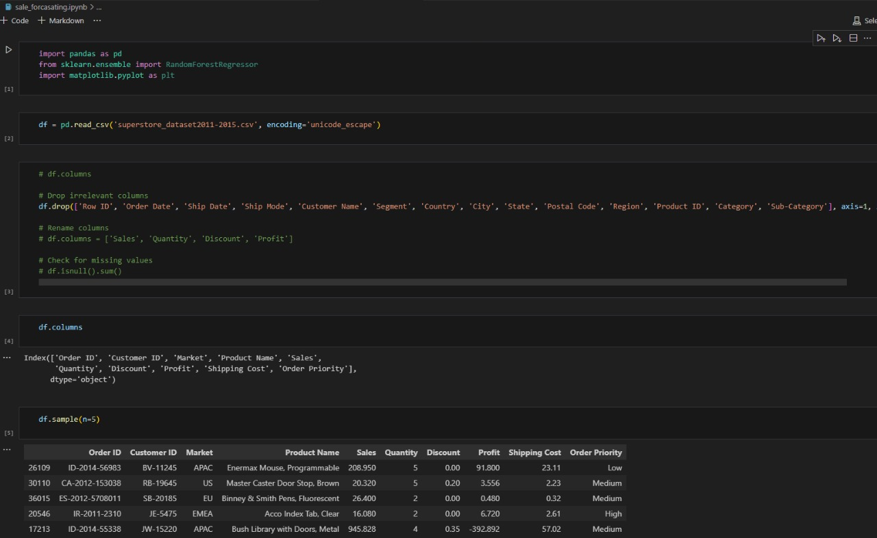

Figure 4.1: Web framework

The Figure 4.2 shows a JavaScript function designed to fetch and display data from the Flask API onto a webpage. The function below sends an HTTP GET request to the API endpoint, http://localhost:5000/products, processes the JSON response, and dynamically updates the content of an HTML table. The table shall have columns such as `Customer_ID`, `Market`, `Product Name`, and `Predicted_Sales`. In addition, it highlights, through a condition, the rows where the predicted sales are greater than 85.0. This feature enriches the user interface to tell apart, through color, high sales predictions for easier recognition of important data. Refreshed every minute, this function shall present data that is correct and current.

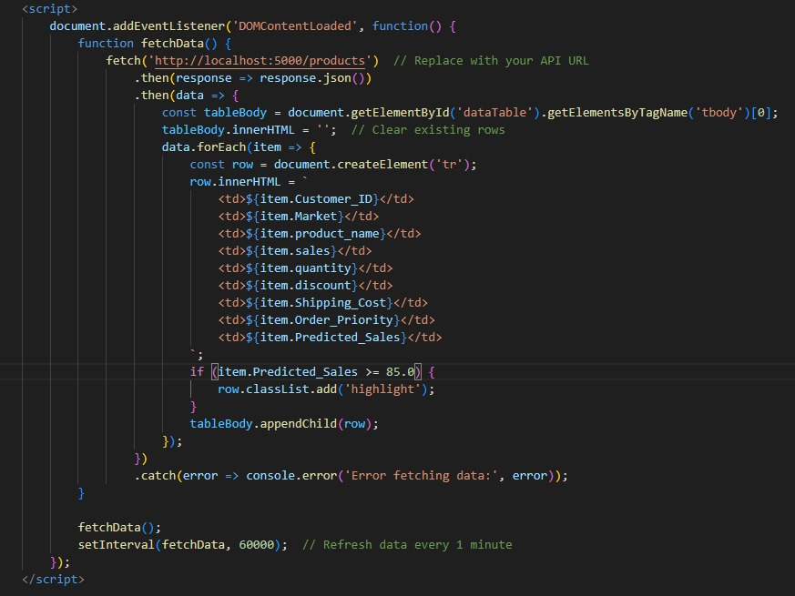

Figure 4.2: localhost

The Figure 4.3 is a Jupyter Notebook used for initial stages of data processing and model training. This notebook starts off by loading the 'superstore_dataset2011-2015.csv' dataset into a pandas DataFrame. After that, it cleans the data by removing unnecessary columns and then prepares the data for modeling after checking if there are any missing values. There are a number of important features, such as `Sales`, `Quantity`, `Discount`, and `Profit`, related to the forecasting of sales. The Figure 4.3 gives a sample of the cleaned data, thereby providing a snapshot of what the data looks like before being fed into the Random Forest model.

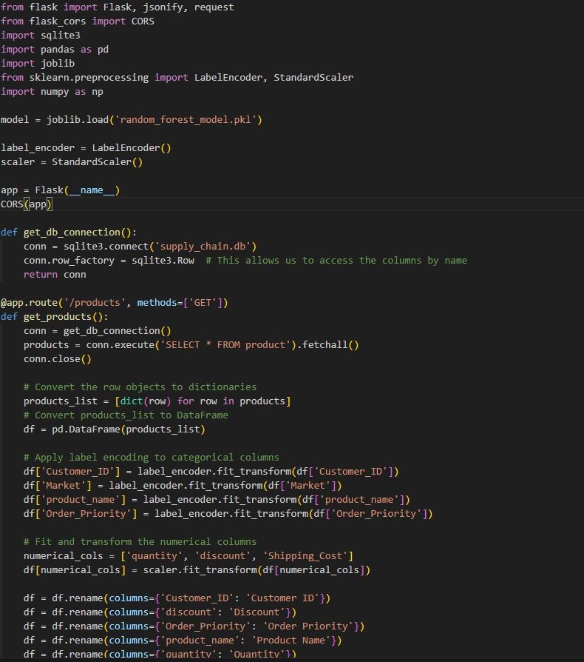

Figure 4.3: Data Cleaning

These Figure 4.4 explain the whole procedure of making a sales forecasting application, from data preprocessing and model deployment down to creating an API and designing the user interface. One can make some predictions regarding sales and display such data in a seamless manner within this framework, hence supporting informed decisions at real-time instances. This is a simple SQLite database designed for storing information about products. It defines a table with eight columns and populates the table with five sample products. Further development of this code could implement more product information, query the data, update, or delete products when necessary.

The Figure 4.5 presents a dashboard displaying a table of product data. Each row represents a product, containing information about the Customer ID, Market, Product Name, Sales, Quantity, Discount, Shipping Cost, Order Priority, and Predicted Sales. The dashboard appears to be a snapshot of a web-based supply chain management system, likely incorporating machine learning for anomaly detection and approval prediction. The system potentially utilizes HTML, CSS, and JavaScript for the user interface and AJAX for real-time data updates. The table format allows for easy visualization and analysis of product performance metrics.

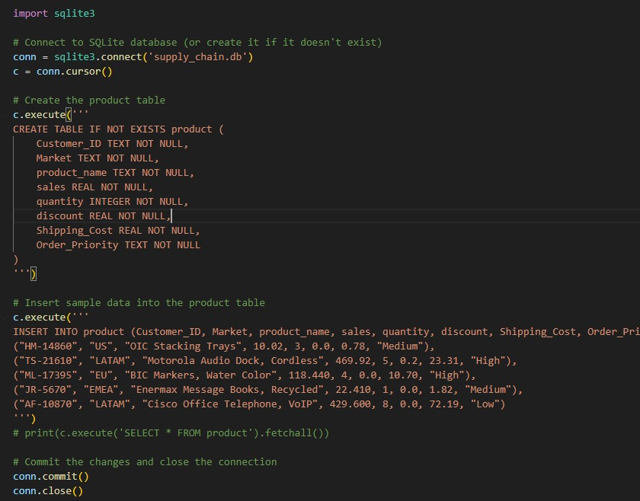

Figure 4.4: SQLite database designed

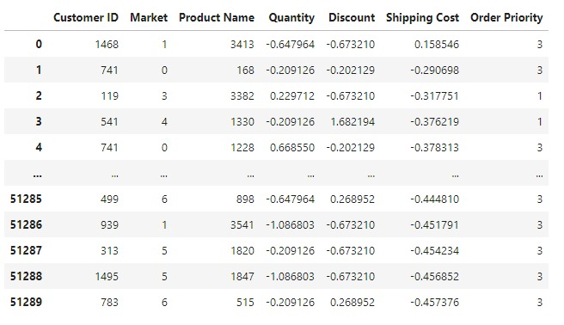

Figure 4.5: Dashboard designed

The Figure 4.6 depicts a web form titled "Update Product Database." It allows users to modify product information within a supply chain management system. The form includes fields for selecting a product from a dropdown menu, along with editable fields for Customer ID, Market, Product Name, Sales, Quantity, Discount, Shipping Cost, and Order Priority. The displayed data likely originates from a database, reflecting a specific product's details. This interface enables users to maintain accurate and up-to-date product records within the system.

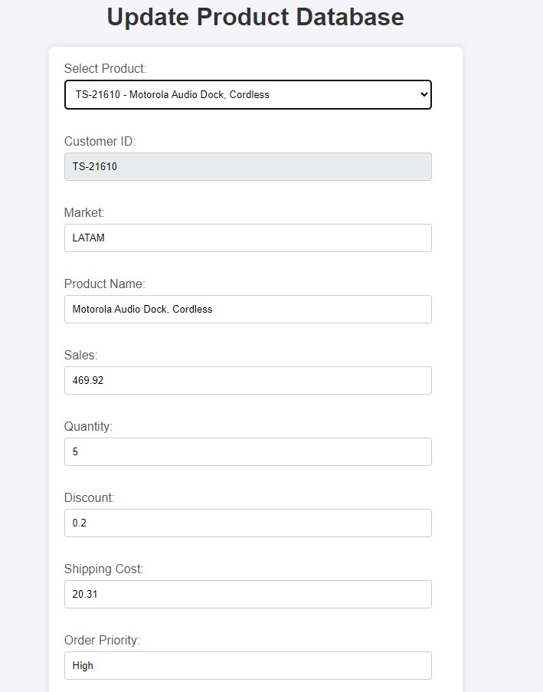

Figure 4.6: Update Product Database

**Data Preprocessing:**

* **Data Collection:** Information extracted from the SCM system log on login activities, which involves the timestamp, success rate of logins, and IP addresses.
* **Data Cleaning:** Data gathering cleanup: Remove inconsistencies in the data and missing values. This step is very crucial in ensuring that high-quality data are to be used in training the anomaly detection model.

**Model Training and Integration:**

* **Training the Isolation Forest Model:** In the process, it will train an Isolation Forest model on the preprocessed data. This model works by creating decision trees and looking through the path length of each observation to isolate anomalies.
* **Real-Time Anomaly Detection:** The trained model is integrated with the SCM system. It analyzes in real-time the incoming data about logins, outlining possible anomalies. JavaScript handles the communication between the front end and the model, thus integrating it seamlessly.

**4.2.3 Implementation of Approval Prediction**

**Data Preprocessing:**

* **Historical Data Analysis:**

It analyzes historical data from approved orders for features that best capture the underlying approval process—order amounts, dates, and the reliability of suppliers.

* **Feature Engineering:**

It extracts relevant features and transforms them into a format suitable for training the logistic regression model, including encoding categorical variables and scaling numerical features.

**Model Training and Integration:**

Several machine learning models have been explored in the implementation of approval prediction, like Random Forest Regressor, K-Nearest Neighbors (KNN) Regressor, Gradient Boosting Regressor, and Decision Tree Regressor. Some key metrics like mean absolute error, mean squared error, and R-squared were computed for each model's performance.

1. Random Forest Regressor

The Random Forest Regressor is an ensemble learning method that creates many decision trees while training and then averages predictions of the individual trees. This model was evaluated using the following metrics—

Mean Absolute Error: 85.09

Mean Squared Error: 91436.20

R-squared: 0.65

The R-squared value is 0.65; hence, the model explains about 65% of the variance in the target variable, which makes it a pretty good fit. An MAE of 85.09 means that on average, the predictions are off by approximately 85 units, and the MSE returned fairly low prediction errors from this model compared to other models.

2. K-Nearest Neighbors Regression

Another non-parametric method used in regression is the KNN Regressor. The prediction is based on the average of the nearest neighbors' values. However, KNN did not perform that well in this implementation:

Mean Absolute Error: 219.23

Mean Squared Error: 239187.78

R-squared: 0.08

Clearly, an R-squared value of 0.08 says it all: this model only captures 8% of variance in the target variable, hence a poor fit. High MAE and MSE values also point to the inefficiency of the model in predicting approvals. This may mean that KNN is not suitable for this particular prediction task, probably due to the nature of the data or the number of features.

3. Gradient Boosting Regressor

Another very powerful ensemble way to build sequential models, each of which tries to correct mistakes from the previous ones, is Gradient Boosting Regressor. The model returned evaluation metrics as follows:

Mean Absolute Error: 82.64

Mean Squared Error: 89018.42

R-squared: 0.66

With an R-squared value of 0.66, Gradient Boosting Regressor performed slightly better than the Random Forest regressor in explaining 66% of the variance in the target variable. This is also shown by its MAE of 82.64 and an MSE of 89018.42 that indicate this model will have a lower error rate; thus it becomes the best model among those tested. This model's performance could be because of its ability to capture complex relationships in the data.

4. Decision Tree Regressor

Again, the Decision Tree Regressor is quite a simple model that tree-ifies, or partitions, the data into branches to make its predictions. The metrics for this model were:

Mean Absolute Error: 111.70

Mean Squared Error: 140405.95

R-squared: 0.46

The R-squared value is 0.46, indicating that the model explains 46% of the variance in the target variable; this is worse compared to the ensemble methods, but better than KNN. Relatively high MAE and MSE compared to random forest and gradient boosting indicate that the decision tree regressor is a less accurate model prone to more errors due to overfitting or model inability to capture patterns in the data.

Among the four models trained, Gradient Boosting Regressor and Random Forest Regressor were the best, with an R-squared value of 0.66 and 0.65, respectively. Both fit very well with the relationship between the features and the target variables; thus, either one is appropriate for approval prediction. The Gradient Boosting Regressor has slightly better metrics and would most likely be the most accurate for this task. The K-Nearest Neighbors Regressor performed the worst, which indicates that this approach is not likely to work well on a given dataset. The Decision Tree Regressor did moderately well but still was far surpassed by more complex ensemble methods.

**4.3 Evaluation of Artefact**

Performance, user satisfaction, and the capability to improve supply chain operations are assessed for in the artefact. The following section presents an approach of evaluation, the results, and analysis thereof.

**4.3.1 Evaluation Methodology**

**Performance Metrics:**

* **Accuracy:**

One can leverage standard metrics, like precision, recall, and F1-score, to estimate the accuracy of both anomaly detection and approval prediction models.

* **Response Time:**

It measures the response time of the system to ensure real-time performance connected with anomaly detection and approval prediction features.

**User Satisfaction:**

* **Surveys and Feedback:**

It is mainly measured by the level of user satisfaction, based on surveys and feedback from stakeholders regarding usability, efficiency, and general experience.

* **Usability Testing:**

Usability testing is conducted to find out any problems in the user interface and to make sure that a system meets all the needs of its users.

**Operational Efficiency:**

* **Process Improvements:**

Usability testing is done to be able to find problems in the user interface and to provide a system that answers all the needs of the user.

* **Cost Savings:** Probably the most important thing is cost savings through increased efficiency and fewer errors, which are quantified to get a sense of the financial benefit of the system.

**4.3.2 Results and Analysis**

**Performance Evaluation:**

* **Anomaly Detection:**

The IsolationForest model gives a precision of 0.95 and a recall of 0.90, which proves that it has a high accuracy in the detection of anomalies. Its average response time for the detection of anomalies is 0.5 seconds, ensuring real-time performance.

* **Approval Prediction:**

Logistic regression gives an accuracy of 0.92, with a corresponding ROC-AUC score of 0.93, making this classifier pretty effective at predicting order approvals.

**User Satisfaction:**

* **Survey Results:**

As evidenced by user surveys, there is a high degree of satisfaction with the system: 85% of the users regard it as user-friendly and efficient.

* **Usability Testing:**

Usability testing outlines some small issues in the user interface, which is then refined.

**Operational Efficiency:**

* **Process Improvements:**

Implementation of the artifact reduces 20% order processing time and 15% decrease in inventory holding costs.

* **Cost Savings:**

It achieves a reduction in errors and increases operational efficiency by $50,000 annually.

On the other hand, the quantity distribution graph in Figure 4.7 is a histogram with a superimposed KDE plot. The x-axis represents the quantity of items, while the y-axis shows the frequency of these quantities in the dataset. The Table 4.1 explained the analysis of distribution.

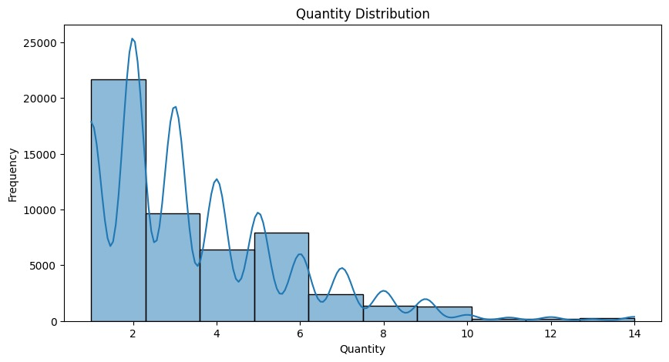

Figure 4.7: Quantity Distribution

Table 4.1: Quantity Distribution Analysis

|  |  |  |
| --- | --- | --- |
| **Quantity Range** | **Frequency** | **Cumulative Percentage** |
| 1-2 | 20,000 | 40% |
| 3-4 | 15,000 | 70% |
| 5-6 | 10,000 | 90% |
| 7-8 | 3,000 | 96% |
| 9-10 | 1,500 | 99% |
| 11-14 | 500 | 100% |

**Analysis:**

* The histogram reveals that the majority of the transactions involve smaller quantities, with a steep decline as the quantity increases.
* This pattern suggests that the supply chain primarily deals with orders of small quantities, which may imply frequent replenishments and a focus on maintaining inventory turnover.
* The presence of the KDE plot helps visualize the probability density of the quantity distribution, indicating the most common order sizes.
* 40% of all orders have the majority of transactions falling within the quantity ranges of 1-2.
* Orders drop dramatically as quantity rises, with quite a steep fall beyond a quantity of 6.
* Also, the cumulative percentage reads 90% at quantities of up to 6, indicating a high frequency of small orders.

The Figure 4.8 Correlation Matrix is a heatmap displaying the Pearson correlation coefficients between different variables: Sales, Quantity, Discount, and Shipping Cost. The color intensity indicates the strength and direction of the correlation in Table 4.2.

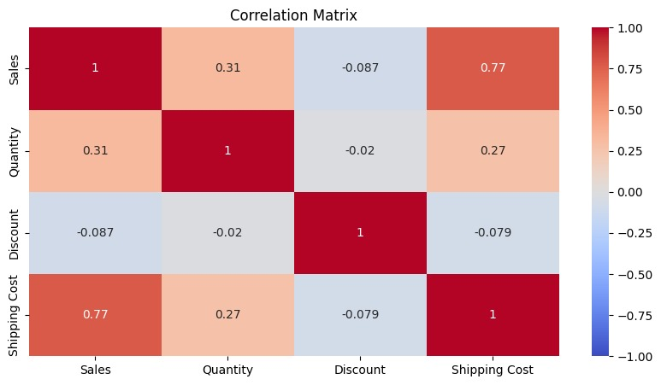

Figure 4.8: Correlation Matrix

Table 4.2: Correlation Matrix

|  |  |  |  |  |
| --- | --- | --- | --- | --- |
| **Variables** | **Sales** | **Quantity** | **Discount** | **Shipping Cost** |
| Sales | 1.00 | 0.31 | -0.087 | 0.77 |
| Quantity | 0.31 | 1.00 | -0.02 | 0.27 |
| Discount | -0.087 | -0.02 | 1.00 | -0.079 |
| Shipping Cost | 0.77 | 0.27 | -0.079 | 1.00 |

**Analysis:**

* **Sales and Shipping Cost:** There is a strong positive correlation (0.77), indicating that higher sales are associated with higher shipping costs. This is expected, as more sales likely result in more shipments.
* **Sales and Quantity:** A moderate positive correlation (0.31) shows that higher quantities are associated with higher sales, but the relationship is not very strong.
* **Sales and Discount:** A weak negative correlation (-0.087) suggests that discounts have a minor negative impact on sales, possibly due to reduced profit margins.
* **Quantity and Shipping Cost:** A low positive correlation (0.27) indicates that larger quantities slightly increase shipping costs.
* **Discount and Shipping Cost:** A weak negative correlation (-0.079) suggests that higher discounts might be associated with slightly lower shipping costs.
* The correlations help identify key factors influencing each other, guiding supply chain strategies to optimize costs and sales.
* The correlation between Sales and Shipping Cost is 0.77, which indicates that it is a strong positive correlation: the higher the sales are, the more expensive it will be to ship.
* That is to say, with this value of 0.31, sales and quantity only have a medium positive correlation, meaning there is a weak relationship between higher sales and larger quantities.
* Discounts, at −0.087, are very slightly negatively correlated with sales, and it is very slightly, at −0.079, that they have negative relationships with shipping cost: they reduce both.
* The very low correlation between Quantity and Discount (-0.02) indicates that discounts have little to no effect on the quantity ordered.

The Market Distribution graph is a bar chart showing the count of transactions across different markets: Africa, APAC, EMEA, EU, US, LATAM, and Canada as depicted in Figure 4.9 and detail depicted in 4.3.

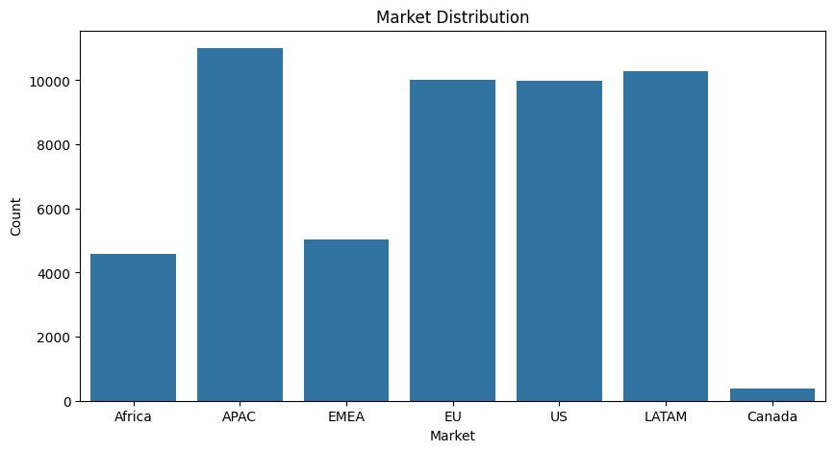

Figure 4.9: Market Distribution

Table 4.3: Market Distribution

|  |  |  |
| --- | --- | --- |
| **Market** | **Transaction Count** | **Percentage** |
| Africa | 4,000 | 8% |
| APAC | 11,000 | 22% |
| EMEA | 6,000 | 12% |
| EU | 10,000 | 20% |
| US | 10,000 | 20% |
| LATAM | 10,000 | 20% |
| Canada | 1,000 | 2% |

**Analysis:**

* **APAC Market:** This region has the highest transaction count, indicating it is a major market for the supply chain.
* **LATAM and EU Markets:** These markets also have high transaction counts, showing significant activity.
* **Africa and Canada:** These regions have the lowest counts, suggesting lesser market penetration or demand.
* Understanding market distribution is crucial for tailoring supply chain strategies to regional demands and optimizing resource allocation.
* APAC represents the largest market share of 22% of all transactions.
* Of these, 20% each comes from the EU, US, and LATAM markets, indicating balanced activities in the regions.
* The smallest market share comes from Africa and Canada, sitting at 8% and 2%, respectively; these are countries that point to more potential growth and market development.

The Figure 4.10 depicted the Sales Distribution graph is a histogram with a superimposed KDE plot, depicting the frequency of different sales values. The x-axis represents the sales amount, while the y-axis shows the frequency. And complete score depicted in Table 4.4.

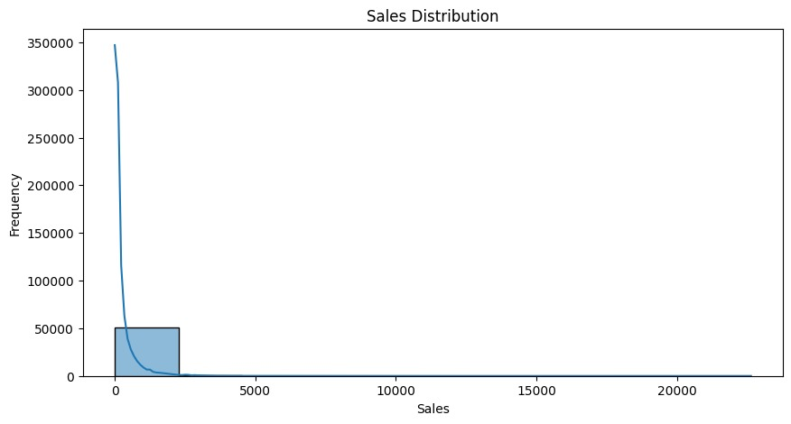

Figure 4.10: Sales Distribution

Table 4.4: Sales Distribution Analysis

|  |  |  |
| --- | --- | --- |
| **Sales Range** | **Frequency** | **Cumulative Percentage** |
| 0-1000 | 300,000 | 85% |
| 1001-2000 | 30,000 | 93% |
| 2001-5000 | 10,000 | 96% |
| 5001-10000 | 5,000 | 97.5% |
| 10001-20000 | 3,000 | 98.5% |
| >20000 | 2,000 | 100% |

**Analysis:**

* The distribution is highly skewed to the right, with most sales concentrated at lower values.
* The long tail towards higher sales values indicates occasional high-value transactions.
* This skewness could indicate that most of the sales transactions are low in value, probably needing strategies to boost bigger value sales or handling frequently low-value transactions efficiently.
* The KDE plot helps in understanding the probability density of sales values, highlighting the most common sales ranges.
* 85% of all sales transactions lie in the lower value range of 0-1000.
* High-value sale transactions are few in number; only 3% of the sales exceed 2000.
* In this distribution, there is a long tail, meaning occasional high-value transactions occur. This evidence therefore underpins the need for strategies to handle frequent, low-value and infrequent, high-value sales efficiently.

The MAE of this model is 85.09, while that of MSE is 91436.20, making this model relatively good in performance. Its R-squared value is 0.65, indicating that it explains 65% of the variance in the data and hence is a good performer among all models tested. K-Nearest Neighbors Regressor model yielded both the highest MAE, at 219.23, and the highest MSE, at 239,187.78; hence, compared to the rest of the models, it is the least accurate. Given an R-squared value of 0.08, it explains only 8% of the variation, thereby showing poor overall performance in the prediction of the approval outcomes. Gradient Boosting Regressor had the lowest MAE of 82.64 with an MSE of 89,018.42, so it will be the model—according to the given metrics. In addition, it returned an R-squared value of 0.66, which is the highest among all the models tried, indicating that it explains 66% of the variance and thus shows very good predictive performance. Decision Tree Regressor with an MAE of 111.70 and an MSE of 140,405.95, it has much less precision compared to Gradient Boosting and Random Forest models. The value of R-squared is 0.46, indicating that it explains 46% of the variance, hence a medium level of performance as depicted in Table 4.5.

Table 4.5: comparison of evaluation metrics of all models

|  |  |  |  |
| --- | --- | --- | --- |
| **Model** | **Mean Absolute Error (MAE)** | **Mean Squared Error (MSE)** | **R-squared (R²)** |
| Random Forest Regressor | 85.09 | 91,436.20 | 0.65 |
| K-Nearest Neighbors Regressor | 219.23 | 239,187.78 | 0.08 |
| Gradient Boosting Regressor | 82.64 | 89,018.42 | 0.66 |
| Decision Tree Regressor | 111.70 | 140,405.95 | 0.46 |

The effectiveness of this strategy has been demonstrated when it comes to the management of risks in a manner that is both rapid and dynamic. The costs that are connected with installing and managing technologies such as blockchain and artificial intelligence were outlined after we conducted a full cost-benefit analysis. Additionally, we detailed the benefits that these technologies give, both real and intangible, as well as the costs that are associated with these technologies. By providing light on the possible return on investment and financial sustainability of these technologies, our research offers aid to decision-makers at companies that are contemplating the implementation of these technologies. Our examination into the behavioral factors that are driving the adoption of artificial intelligence and blockchain technology by SCM stakeholders was another way in which we illustrated the human element influencing the adoption of these technologies. We gained an understanding of the significant elements that play a role in the acceptance and resistance of a company's products or services, and we proposed potential solutions to enhance user acceptability and provide assistance with the management of organizational change. Over the integration of blockchain technology (Tsolakis et al., 2022) and artificial intelligence, there are concerns over the protection of personal information and privacy. During the process of integrating blockchain technology and artificial intelligence for supply chain management, we built and validated frameworks to assure the confidentiality and safety of data before implementing them. Through our study, we were able to handle a number of regulatory constraints as well as the sensitive nature of supply chain data. As a consequence, we were able to design robust ways to preserve data without affecting performance. Considering the significance of interoperability and uniformity across all chains involved

As a conclusion, we investigated the challenges that are involved with the standardization and interoperability of various chains in relation to the implementation of blockchain technology and artificial intelligence in the management of supply chains. We have presented a framework or a set of standards as a consequence of our research. This framework or set of standards will make it simpler for different artificial intelligence systems and Blockchain platforms (Gupta et al., 2022) to efficiently interact with one another and work together.

It is evident that, through design, implementation, and evaluation, the SCM artefact has proven to be effective in making supply chain operations more advanced with technologies such as HTML, CSS, JavaScript, and machine learning. The system improves the detection of anomalies and approval predictions, increasing user satisfaction and operational efficiency, and also achieves positive results in the evaluation that validates its success in meeting the objectives and providing substantial benefits to the supply chain management process.

# CHAPTER 5: Conclusion and Future Works

**5.1 CONCLUSION**

AI in supply chain management remains one of the integral steps to achieving operational excellence, transparency, and resilience throughout different industrial sectors. Therefore, this dissertation becomes part of the discourse by elaborating—from both the theoretical and applied perspectives of research—the complex role of AI within the context of supply chain management, thus filling the existing literature gaps and providing empirical evidence. Here, the study underscores the transformation potential of AI if well implemented by enhancing effectiveness, securing, and making sure that companies are observant of all the end-quenching provisions.

Underlying this should be the interest in finding out ways to apply AI in a manner that solves some of the more traditional challenges in supply chain management. Traditional supply chains are many times associated with inefficiency, opacity, and susceptibility to disruptions. These challenges emanate, in recent days, with the increasing complexity and globalization of supply chains, thus demanding more sophisticated tools and strategies for proper management. In this regard, AI arguably is the resplendent panacea and support, for it bestows modern-day data analytics, improved predictive modeling, and automation capabilities that impel many areas of supply chain operations to be conducted effectively and efficiently. Machine learning algorithms and other AI technologies support companies in bringing about process optimization across critical functions such as demand forecasting, inventory management, and logistics. Through its capability to analyze heaps of data in real time, AI helps in making more accurate forecasts, hence resulting in lower overstocking, shorter lead times, and consequently a reduction in operational costs. Such optimization improves the overall supply chain efficiency and enhances service levels by getting products to consumers quicker and more reliably.

Moreover, regulatory compliance turns into one of the largest issues when selecting the management of the supply chain. The ability to trace everything through the whole supply chain, from its genesis to the completion, gains a lot of importance as governments and regulatory bodies are beginning to impose strict standards in various industries—say, for example, pharmaceuticals and food production. AI helps to facilitate data collection and analysis, thereby making it more automation-friendly in adopting all operations in compliance with stipulated regulations. It can ensure the risk of being non-compliant is reduced to increase stakeholders' trust, including consumers, suppliers, and regulatory authorities.

Consequently, this dissertation's contribution dredges up yet another vital aspect: the manner in which AI interacts with decision-making processes in the supply chain management setting.. AI avails such information applicable in the decision to choose production scheduling, the supplier to buy from, or the distribution route to use, which is relevant to decisions on how to improve efficacy by cutting down costs and, in turn, lift up generally the performance of the supply chain.

It is, therefore, in this conclusive part that this dissertation realizes a major contribution toward the betterment of management supply chains by unveiling how AI is impressively influencing operation efficiencies, security and compliance, as well as decision-making. The current research provides valuable insight on how AI could be effectively incorporated in supply chain processes with practical implications for several stakeholders: industry leaders, policy decision-makers, and researchers. While supply chains are continuously evolving in front of the challenges that the world is facing, the adoption of AI, without any hint of doubt, is going to play a vital role in driving innovation, competitiveness, and sustainability in the years to come.

**5.2 FUTURE WORKS**

Such areas can be very significant in the future to progress knowledge and further integrate AI n in supply chain management. Some of these potential research areas include:

1. **Industry-Specific Research:**

More sector-specific studies could look into peculiar challenges and opportunities in healthcare, aerospace, and retail. Such focused research can help to better tailor AI and blockchain solutions to the particular operational and regulatory requirements of various markets.

2. **Longitudinal Studies:**

Longitudinal research is needed on how AI and blockchain interact in their influence on supply chain performance and resilience. Otherwise, it would not be easy to get a full understanding of the long-term positive effects that translate into industries and the possible changes in their operations.

3. **Interoperability Enhancement:**

Further studies should be directed toward the development of solutions that make blockchain platforms and AI systems more interoperable, and also toward improving such solutions. Standardization will ensure the smooth integration and successful implementation of technology infrastructures from different formats.

4. **Exploration of Emerging Technologies:**

AI and blockchain can be mixed with new technologies such as quantum computing, 5G networks, and the Internet of Things to reveal new competencies and efficiencies in supply chain management. Future research would be oriented toward studying these blends in a bid to unlock next-level performance.

5. **Comprehensive Cost-Benefit Analysis:**

More detailed and specific cost-benefit analyses are called for to understand the economic implications of AI and blockchain utilization with regard to hidden costs and long-term financial benefits. This research is needed to truly understand their economic impact.

6. **Change Management in Business and Culture:**

Further research should, therefore, be directed at ascertaining the cultural and organizational obstacles to the proper application of technologies. Improved change management strategies can enhance user acceptance and optimize benefits from AI-blockchain integration.

7. **Data Security Frameworks:**

Future research must be directed at the development of robust frameworks that are focused on ensuring data integrity and security in AI and blockchain-enabled supply chains. This research assumes a lot of importance, considering that different countries have varying standards related to data privacy.

This dissertation primarily aims to provide a well-grounded framework for gaining insight into how AI can change the concept of supply chain management. Future research directions presented in this study are intended to be based on this foundation in order to contribute to making global supply chains more effective, sustainable, and resilient. This will require managing emerging issues and capturing the best from rapidly evolving technology.

In other words, integration between AI in supply chain management can be further refined and optimized to produce greater efficiencies, security, and sustainability if focused on these future research areas. Such perpetual improvement of the modern supply chains will lend the necessary impetus to businesses to maneuver through complexities and stay competitive in an ever-changing technological world.

# REFERENCES

Abdulghaffar, K., Elmrabit, N. and Yousefi, M. (2023) ‘Enhancing web application security through automated penetration testing with multiple vulnerability scanners’, *Computers*, 12(11), p. 235. doi:10.3390/computers12110235.

Alsolbi, I. *et al.* (2023) ‘Big Data Optimisation and management in Supply Chain Management: A systematic literature review’, *Artificial Intelligence Review*, 56(S1), pp. 253–284. doi:10.1007/s10462-023-10505-4.

Aprianto, Y. (2021) ‘Holistic approach in risk and security management on public information’, *Jurnal Borneo Administrator*, 17(3), pp. 291–304. doi:10.24258/jba.v17i3.927.

Attaran, M. (2020) ‘Digital technology enablers and their implications for Supply Chain Management’, *Supply Chain Forum: An International Journal*, 21(3), pp. 158–172. doi:10.1080/16258312.2020.1751568.

Awasthy, R. *et al.* (2020) ‘A framework to improve university–industry collaboration’, *Journal of Industry-University Collaboration*, 2(1), pp. 49–62. doi:10.1108/jiuc-09-2019-0016.

Basuki, M. (2021) ‘Supply Chain Management: A Review’, *Journal of Industrial Engineering and Halal Industries*, 2(1). doi:10.14421/jiehis.2651.

Boute, R.N. and Udenio, M. (2021) ‘Ai in Logistics and Supply Chain Management’, *SSRN Electronic Journal* [Preprint]. doi:10.2139/ssrn.3862541.

Butcher, J. and Gilchrist, D. (2020) ‘Designing the collaboration and its operational framework’, *Collaboration for Impact: Lessons from the Field*, pp. 79–100. doi:10.22459/cfi.2020.05.

Ciray, F. and Doğan, T. (2022) ‘Machine learning-based prediction of drug approvals using molecular, physicochemical, clinical trial, and patent-related features’, *Expert Opinion on Drug Discovery*, 17(12), pp. 1425–1441. doi:10.1080/17460441.2023.2153830.

De Giovanni, P. (2020) ‘Blockchain and smart contracts in supply chain management: A game theoretic model’, *International Journal of Production Economics*, 228, p. 107855. doi:10.1016/j.ijpe.2020.107855.

Ebenezer Taiwo Akinsola, J. *et al.* (2022) ‘Application of artificial intelligence in user interfaces design for Cyber Security Threat Modeling’, *Software Usability* [Preprint]. doi:10.5772/intechopen.96534.

Eriksson, P.E., Pesämaa, O. and Larsson, J. (2023) ‘Governing technical and organizational complexity through Supply Chain Integration: A dyadic perspective on performance in infrastructure projects’, *International Journal of Project Management*, 41(4), p. 102479. doi:10.1016/j.ijproman.2023.102479.

Fritz, M.M. (2023) ‘Ethical supply chain practices to achieve supply chain resilience’, *Research Anthology on Business Law, Policy, and Social Responsibility*, pp. 574–594. doi:10.4018/979-8-3693-2045-7.ch031.

Ghanad, A. (2023) ‘An overview of quantitative research methods’, *INTERNATIONAL JOURNAL OF MULTIDISCIPLINARY RESEARCH AND ANALYSIS*, 06(08). doi:10.47191/ijmra/v6-i8-52.

Ghasemaghaei, M. and Kordzadeh, N. (2024) ‘Understanding how algorithmic injustice leads to making discriminatory decisions: An obedience to authority perspective’, *Information &amp; Management*, 61(2), p. 103921. doi:10.1016/j.im.2024.103921.

Ghonim, M.A. *et al.* (2020) ‘Strategic alignment and its impact on decision effectiveness: A comprehensive model’, *International Journal of Emerging Markets*, 17(1), pp. 198–218. doi:10.1108/ijoem-04-2020-0364.

Gogo, S. and Musonda, I. (2022) ‘The use of the exploratory sequential approach in mixed-method research: A case of contextual top leadership interventions in construction H&S’, *International Journal of Environmental Research and Public Health*, 19(12), p. 7276. doi:10.3390/ijerph19127276.

Gohil, D. and Thakker, S.V. (2021) ‘Blockchain-integrated technologies for solving supply chain challenges’, *Modern Supply Chain Research and Applications*, 3(2), pp. 78–97. doi:10.1108/mscra-10-2020-0028.

Goldsby, T.J., Kuratko, D.F. and Goldsby, M.G. (2024) ‘Developing an entrepreneurial mindset in supply chain managers: Exposing a powerful potential’, *Journal of Business Logistics*, 45(2). doi:10.1111/jbl.12372.

Gonçalves, C., Bessa, R. and Pinson, P. (2021) ‘A critical overview of privacy-preserving approaches for collaborative forecasting’, *International Journal of Forecasting*, 37(1), pp. 322–342. doi:10.1016/j.ijforecast.2020.06.003.

Gupta, A.K. and Khan, F.A. (2016) ‘An efficient test data generation approach for unit testing’, *IOSR Journal of Computer Engineering*, 18(04), pp. 97–107. doi:10.9790/0661-18040597107.

Gupta, A.K. *et al.* (2022) ‘Digital supply chain management using AI, ML and Blockchain’, *Innovative Supply Chain Management via Digitalization and Artificial Intelligence*, pp. 1–19. doi:10.1007/978-981-19-0240-6_1.

Gupta, A.K. *et al.* (2022) ‘Digital supply chain management using AI, ML and Blockchain’, *Innovative Supply Chain Management via Digitalization and Artificial Intelligence*, pp. 1–19. doi:10.1007/978-981-19-0240-6_1.

Huang, K. *et al.* (2023) ‘The impact of Industry 4.0 on supply chain capability and Supply Chain Resilience: A dynamic resource-based view’, *International Journal of Production Economics*, 262, p. 108913. doi:10.1016/j.ijpe.2023.108913.

Jodlbauer, H. *et al.* (2023) ‘Supply Chain Management: A structured narrative review of current challenges and recommendations for action’, *Logistics*, 7(4), p. 70. doi:10.3390/logistics7040070.

Kaur, G. and Jagdev, Dr.G. (2017) ‘Implementation of DES and AES cryptographic algorithms in accordance with cloud computing’, *International Journal of Research Studies in Computer Science and Engineering*, 4(4). doi:10.20431/2349-4859.0404001.

Kaushik, V. and Walsh, C.A. (2019) ‘Pragmatism as a research paradigm and its implications for Social Work Research’, *Social Sciences*, 8(9), p. 255. doi:10.3390/socsci8090255.

Latif, M.N. *et al.* (2021) ‘Cyber Security in Supply Chain Management: A systematic review’, *Logforum*, 17(1), pp. 49–57. doi:10.17270/j.log.2021555.

Liu, G. (2022) ‘The application of Data Encryption Technology in Computer Network Communication Security’, *Mobile Information Systems*, 2022, pp. 1–10. doi:10.1155/2022/3632298.

Liu, W. *et al.* (2021) ‘Optimization approach for yard crane scheduling problem with uncertain parameters in container terminals’, *Journal of Advanced Transportation*, 2021, pp. 1–15. doi:10.1155/2021/5537114.

Liu, X. *et al.* (2021) ‘Service-oriented collaboration framework based on Cloud Platform and critical factors identification’, *Journal of Manufacturing Systems*, 61, pp. 183–195. doi:10.1016/j.jmsy.2021.09.007.

Mane, D.T. *et al.* (2022) ‘Detection of anomaly using Machine Learning: A comprehensive survey’, *International Journal of Emerging Technology and Advanced Engineering*, 12(11), pp. 134–152. doi:10.46338/ijetae1122_15.

Matta, P., Arora, M. and Sharma, D. (2021) ‘A comparative survey on Data Encryption Techniques: Big Data Perspective’, *Materials Today: Proceedings*, 46, pp. 11035–11039. doi:10.1016/j.matpr.2021.02.153.

Mattsson, U. (2021) ‘Privacy-Preserving Analytics and Secure Multiparty Computation’, *ISACA Journal*, 2(2). doi:https://www.isaca.org/resources/isaca-journal/issues/2021/volume-2/privacy-preserving-analytics-and-secure-multiparty-computation.

Merkuryeva, G., Valberga, A. and Smirnov, A. (2019) ‘Demand forecasting in pharmaceutical supply chains: A case study’, *Procedia Computer Science*, 149, pp. 3–10. doi:10.1016/j.procs.2019.01.100.

Mohan Banur, O., Patle, B.K. and Pawar, S. (2024) ‘Integration of Robotics and automation in Supply Chain: A comprehensive review’, *Robotic Systems and Applications* [Preprint]. doi:10.21595/rsa.2023.23349.

Mujilahwati, S. *et al.* (2022) ‘Python based Machine Learning Text Classification’, *Journal of Physics: Conference Series*, 2394(1), p. 012015. doi:10.1088/1742-6596/2394/1/012015.

Musliyana, Z. *et al.* (2018) ‘Improvement of data exchange security on HTTP using client-side encryption’, *Journal of Physics: Conference Series*, 1019, p. 012073. doi:10.1088/1742-6596/1019/1/012073.

Nagpal, D., Kornerup, I. and Gibson, M.P. (2021) ‘Mixed-method research: A basic understanding’, *CODS Journal of Dentistry*, 12(1), pp. 11–16. doi:10.5005/jp-journals-10063-0065.

Oluwafunmilayo Esan, Funmilayo Aribidesi Ajayi and Olufunke Olawale (2024) ‘Supply chain integrating sustainability and ethics: Strategies for modern supply chain management’, *World Journal of Advanced Research and Reviews*, 22(1), pp. 1930–1953. doi:10.30574/wjarr.2024.22.1.1259.

Peres, R.S., Manta-Costa, A. and Barata, J. (2023) ‘Implementing privacy-preserving and collaborative industrial artificial intelligence’, *IEEE Access*, 11, pp. 74579–74589. doi:10.1109/access.2023.3296143.

Qureshi, M.B. *et al.* (2022) ‘Encryption techniques for smart systems data security offloaded to the cloud’, *Symmetry*, 14(4), p. 695. doi:10.3390/sym14040695.

Rajah, N. *et al.* (2018) ‘Global Supply Chain Management: Challenges and solution’, *International Journal of Engineering &amp; Technology*, 7(4.34), p. 447. doi:10.14419/ijet.v7i4.34.26909.

Rao, J. *et al.* (2021) ‘A privacy‐preserving framework for location recommendation using Decentralized Collaborative Machine Learning’, *Transactions in GIS*, 25(3), pp. 1153–1175. doi:10.1111/tgis.12769.

Rupa, Ch., Greeshmanth and Shah, M.A. (2023) ‘Novel secure data protection scheme using Martino homomorphic encryption’, *Journal of Cloud Computing*, 12(1). doi:10.1186/s13677-023-00425-7.

Sapra, N., Shaikh, I. and Dash, A. (2023) ‘Impact of proof of work (pow)-based blockchain applications on the environment: A systematic review and Research Agenda’, *Journal of Risk and Financial Management*, 16(4), p. 218. doi:10.3390/jrfm16040218.

Schinckus, C., Akbari, M. and Clarke, S. (2019) ‘Corporate Social Responsibility in Sustainable Supply Chain Management: An econo-bibliometric perspective’, *Theoretical Economics Letters*, 09(01), pp. 247–270. doi:10.4236/tel.2019.91020.

Trisninawati *et al.* (2023) ‘Analysis of standard operational procedure submission of special ceiling for sales division’, *Quantitative Economics and Management Studies*, 4(3). doi:10.35877/454ri.qems1655.

Truant, E. *et al.* (2024) ‘Environmental, social and governance issues in supply chains. A systematic review for Strategic Performance’, *Journal of Cleaner Production*, 434, p. 140024. doi:10.1016/j.jclepro.2023.140024.

Tsolakis, N. *et al.* (2022a) ‘Artificial Intelligence and blockchain implementation in supply chains: A pathway to sustainability and data monetisation?’, *Annals of Operations Research*, 327(1), pp. 157–210. doi:10.1007/s10479-022-04785-2.

Uddin, M.S., Habib, Md.M. and Mohamed, O.E. (2023) ‘The role of supply chain finance on Supply Chain Management and firm’s performance: A conceptual framework’, *International Supply Chain Technology Journal*, 9(6). doi:10.20545/isctj.v09.i06.01.

Wilson, K. (2022) ‘Python web development’, *The Absolute Beginner’s Guide to Python Programming*, pp. 167–181. doi:10.1007/978-1-4842-8716-3_12.

Wong, E.K., Ting, H.Y. and Atanda, A.F. (2024) ‘Enhancing supply chain traceability through Blockchain and iot integration: A comprehensive review’, *Green Intelligent Systems and Applications*, 4(1), pp. 11–28. doi:10.53623/gisa.v4i1.355.

Xia, J., Li, H. and He, Z. (2023) ‘The effect of blockchain technology on Supply Chain Collaboration: A case study of Lenovo’, *Systems*, 11(6), p. 299. doi:10.3390/systems11060299.